Teachers’ notes Level B1.2

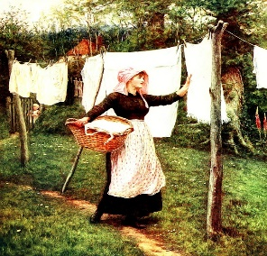
Lesson outcomes
By the end of the lesson students will have:
- learned about International Women’s Day.
- listened to people speak about women that inspire them.
- discussed the topic with classmates.
- considered attitudes towards women.

Materials
Handout for students
https://learnenglish.britishcouncil.org/general-english/video-zone/international-womens-day-who-inspires-you
Appendices
PPT
All images taken from Pixabay.com

Time | Procedure | Materials
5 minutes | Activity 1: International Women’s Day.  - Display lesson objectives.  - Ask students if anyone knows the history of International Women’s Day. Check out International Women’s Day on Wikipedia.org or www.internationalwomensday.com and especially the terrible fire of March 25th 1911. | PPT
15  minutes  20 minutes  10 minutes | Activity 2: A woman you admire.  - Most of us, both male and female, will have someone we admire or who has inspired us.  - Speak briefly about someone you admire, or read Appendix 1 to the students.  - Make a few suggestions (a singer, actress, politician, writer or even someone in the students’ family) and then put students into pairs or breakout rooms to compare their ideas.  - Bring everyone together and listen to their ideas.  Activity 3: Someone who inspires you.  - The students are going to watch a video about people who have inspired the interviewees.  - First of all pre-teach some vocabulary:  Discrimination=(unfair treatment because of race colour, age, sex or sexual orientation); a refuge=(a place offering protection from danger); to get a degree=(a university qualification); a role model=(an idol or heroine); a slave=(a person who is the property of another person and works without pay); conservation=(the protection of animals and plants); to inspire=(usually a person who motivates and influences you); to put on a brave face=(to appear calm).  https://learnenglish.britishcouncil.org/general-english/video-zone/international-womens-day-who-inspires-you  Ask students to watch the video and concentrate on these names: Alexandria Orasio Cortez; Leslie Feinburg; Phyllis Wheatley; Marie Colvin; J.K.Rowling; Dian Fossey. What do the students learn about them from the video? Why are they inspiring?  Activity 4: Watch again  - This time distribute the Activity (Appendix 2 and on the Ppt) and ask students to read the short quotes.  - Watch again. These sentences are about various people who inspired the speakers on the video. In pairs, students match the quote with the person who inspired it.  - Which of the women do students find most inspiring?
10 minutes | Reflection Attitudes towards women  - How do the students usually find people’s attitudes towards women? Ask them to think about their area, their own family, a place they have lived before, a workplace, entertainment venue, public place or even school.  - Discuss any injustices or discrimination they have found.  - Do the boys agree or disagree? What is their opinion?

Students’ handout

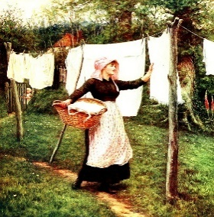
Lesson Outcomes

By the end of the lesson you will have:
- learned about International Women’s Day.
- listened to people speak about women that inspire you.
- discussed the topic with classmates.
- considered attitudes towards women.

Activity 1: International Women’s Day
- Does anyone know the history of International Women’s Day? Check out International Women’s Day on www.wikipedia.org
or www.internationalwomensday.com and especially the terrible fire of March 25th 1911.

Activity 2: A woman you admire.
- Most of us, both male and female, will have someone we admire or who has inspired us.
- Listen to the teacher speak briefly about someone he/she admires, or read Appendix 1.
- Think of someone you admire, a singer, actress, politician, writer or even someone in your family.
- In pairs or breakout rooms compare your ideas.
- Listen to each other’s ideas.

Activity 3: Someone who inspires you.
- You are going to watch a video about people who have inspired the interviewees.
- First of all look at the glossary below.
- Watch the video and concentrate on these names:
Alexandria Orasio Cortez; Leslie Feinburg; Phyllis Wheatley; Marie Colvin; J.K.Rowling; Dian Fossey.
- What do you learn about them from the video? Why are they inspiring?
Activity 4: Read and watch again.
- Look at the Activity worksheet (Appendix 2 and on the Ppt) and read the short quotes.
- Watch the video again. These sentences are about various people who inspired the speakers on the video. In pairs, match the quote with the person who inspired it.
- Which of the women do you find most inspiring?

Reflection Attitudes towards women

- What is your personal experience of people’s attitudes towards women? Think about the area where you live, your own family, a place you have lived before, a workplace, entertainment venue, public place or even school.
- Discuss any injustices or discrimination you have found.
- Do the boys agree or disagree? What is their opinion?

Glossary
Discrimination= unfair treatment because of race colour, age, sex or sexual orientation. A refuge= a place offering protection from danger. To get a degree= a university qualification. A role model= an idol or heroine. A slave= a person who is the property of another person and works without pay. Conservation= the protection of animals and plants. To inspire= usually a person who motivates and influences you. To put on a brave face= to appear calm when you aren’t really.

Appendix 1 Velia
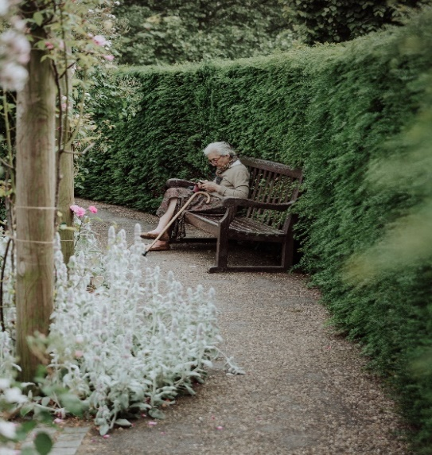

Velia was my children’s babysitter when my husband and I were both working full time. She was already in her late 70’s and provided the comforting image of a loving grandmother. She enjoyed spoiling them with their favourite food, home made gnocchi with butter and sage and zabaglione cream dessert.

For me, she was especially memorable for the way she lived her life before I knew her. First of all, she married a fairly wealthy man, but was not afraid to leave him and return home when he started coming home drunk and treated her badly.

Then, she collaborated with the Partisans as a teenager during the second world war, conveying messages to the groups of soldiers hiding in the Dolomites. Her family lived near the main railway line from Venice to Trieste and she regularly used to go there with her sister to offer wet sponges of water held up on long sticks, to the wagons of people being transported like animals to the Concentration camps in Austria and Germany.

Finally, her brother-in-law deserted, ran away from, the army during the war and the sisters kept him hidden in their chicken shed throughout the rest of the war. Whenever someone came to the house to ask about their brother, or search for him, they risked their lives defending him. They insisted he wasn’t there and that they had no idea where he was.

An admirable lady indeed, deserving of but receiving no recognition. Her house still stands empty. The garden is neglected, but the chicken shed is there.
Appendix 2
Who are the interviewees speaking about?

Watch the video and choose from the following:
Marie Colvin, my mum (3 times), Leslie Feinburg, my friend Kate in Guatemala, Alexandria Ocasio-Cortez , my grandmother, Dian Fossey, J.K.Rowling, my aunt, Phyllis Wheatley.

- … just a phenomenal woman, when conservationism wasn’t cool, it wasn’t trendy.

- She was a kind, loving amazing human being.

- She was the first person in her family to get a degree.

- It was the first book to be published by an African-American woman ever.

- She helps women who are experiencing sexual violence find safety in a refuge.

- She has told me to go after what I want in life and take every opportunity.

- She just inspires me with her capability.

- She was perhaps the bravest woman to ever be a journalist.

- She always puts on a brave face, puts her family first and is always super-positive.

- She was brave enough to live as a butch lesbian despite the discrimination she faced.

- She managed to make this massive contribution to children’s literature.

- She’s going to become a fantastic role model for both young women and young men.

