Teachers’ notes Level B1.2

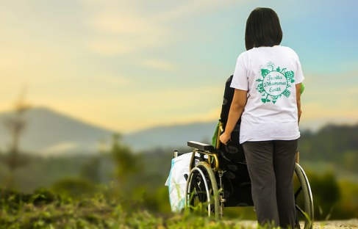
Lesson outcomes
By the end of the lesson students will have:
- thought about the kinds of volunteering people can do.
- read about and discussed why people volunteer.
- read about the advantages of volunteering.
- discussed the pros and cons.

Materials
Handout for students
Appendices
PPT
All images taken from Pixabay.com

Time | Procedure | Materials
5 minutes | Activity 1: Introductory discussion  - Display lesson outcomes  - Ask students if anyone has worked in the community for free.  - What have they done? Did they enjoy it? Why? Why not?  - Why did they decide to volunteer?  - How did they find out about it? | PPT
10 minutes  15 minutes  10 minutes  10 minutes | Activity 2: What can we do?  - The aim of this section is to get students to think “out of the box”. What can we do when we volunteer? Tell them the obvious answers like helping the elderly, doing shopping for them and bringing them medications from the chemist’s.  - In what other ways can we volunteer? Put students into groups of 3 and ask them to note down any ideas they can think of. Set a deadline of 3 minutes.  Eg. Helping children with reading and online schooling; cutting lawns, weeding, cutting back and tidying gardens; helping with foodbanks and food collections; working at a charity shop, thrift shop or church clothes and furniture collections; helping with community lunches and teas; litter-picking; working with animal charities by cleaning, feeding and exercising. They can use also any knowledge and experience they have to help others.  - Go through each group’s ideas quickly, all together.  Activity 3: Volunteer to Career!  - Put students into groups and ask them to read together the different statements made by young volunteers. The statements are in the appendix and on the ppt.  Comprehension check: who …. ?  … volunteered as an usher at the theatre? Megan  … wakes up at 5am? Callum  … saw an ad in the local paper? Ettore  … has learned to do things safely? Amelia  … is out in all weathers? Ali  … distributed food coupons? Ettore  … is now working in children’s theatre? Megan  … was scared at first? Ettore  … is using his skills to teach others? Tanveer  Activity 4: The benefits  - Ask students to read the statements again individually and underline or highlight all the different benefits the volunteers feel they have gained from their experience.  - Go through with them and write them up.  Activity 5:  - Now ask them to read about the proven health benefits of volunteering (Appendix 2 and ppt). Are they the same or different from the volunteer testimonials?  - Are there any extra health benefits not mentioned by the volunteers? Do students think they are realistic?  - Ask them to discuss in pairs and decide the most important. List the important benefits they mention.
10  minutes | Reflection  - Do the students agree with the health benefits of volunteering?  - “Doing good does you good!” Do they agree with Ettore?  - Should volunteers be paid for the work they do?  - “Never give up!” Do students agree with Megan? Why? Why not?  - “Volunteer to career” possible or impossible?

Students’ handout

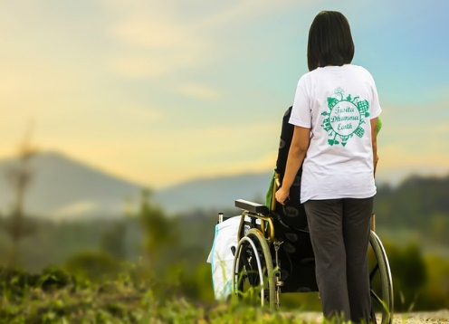
Lesson Outcomes

By the end of the lesson you will have:
- thought about the kinds of volunteering people can do.
- read about and discussed why people volunteer.
- read about the advantages of volunteering.
- discussed the pros and cons.

Activity 1: Introductory discussion
- Has anyone worked in the community for free?
- What have you done? Did you enjoy it? Why? Why not?
- Why did you decide to volunteer?
- How did you find out about it?
Activity 2: What can we do?
- What can we do when we volunteer? Eg. helping the elderly, doing shopping for them and bringing them medications from the chemist’s.
- In what other ways can we volunteer?
- In groups of 3 note down any ideas you can think of.
- Go through your ideas with the teacher.
Activity 3: Volunteer to career?
- In groups read together the different statements made by young volunteers. The statements are in the appendix and on the ppt. Look at the Glossary to help you.
Comprehension check: who …. ?
… volunteered as an usher at the theatre?
… wakes up at 5am?
… saw an ad in the local paper?
… has learned to do things safely?
… is out in all weathers?
… distributed food coupons?
… is now working in children’s theatre?
… was scared at first?
… is using his skills to teach others?
Activity 4: The benefits
- Read the statements again individually and underline or highlight all the different benefits the volunteers feel they have gained from their experience.
Go through them in your groups.
- Come together to tell each other and the teacher.

Activity 5: Health and Well-being
- Now read about the proven health benefits of volunteering (Appendix 2 and ppt).
- Are they the same or different from the volunteer testimonials?
- Are there any extra health benefits not mentioned by the volunteers?
- Do you think they are realistic?
Discuss in pairs and decide the most important. Compare together.
Reflection
- Do you agree with the health benefits of volunteering?
- “Doing good does you good”. Do you agree with Ettore?
- Should you be paid for the work you do?
- “Never give up!” Do you agree with Megan? Why? Why not?
- “Volunteer to career” possible or impossible?

Glossary:
To volunteer = to offer to work for the community without being paid.
To have a skill = to have an ability to do something well, usually learned at school, doing courses or just by working.
A food coupon = a voucher with a money value, to give in exchange for food in a supermarket.
A bat box = a small box, often wood, made for small animals like bats to nest in safely. Usually put in trees or under the house roof.
To be elderly and infirm = refers to older people who can’t stand or walk very well.
To be out in all weathers = refers to working outside in hot, cold, wet, windy, icy or snowy
weather.
To do you good = to do something that will benefit you or improve you in some way. Eg. working outside in the fields does me good. Eg 2. Eating fruit and vegetables does us good.
Appendix 1
What people say about volunteering
Amelia
I started volunteering when I was thinking about what I wanted to do after school. I was interested in conservation work so I volunteered for a Nature Trust. I started planting trees, building bird boxes and bat boxes …. I learned to do things safely and built up my base knowledge. Networking is a big thing in the environmental sector. I’ve made so many friends, feel much happier and more self-confident. I’m now an apprentice conservation officer.
Callum
… I wake up at 5am to work on the farm, collect water and build relationships in the community. The voluntary sector is a perfect chance for young people to gain experience and make themselves employable. I work very long hours, but I’m stronger, mentally and physically, independent of my family, able to make decisions for myself. I’m often tired, but now I know the experience has made me happier and feel fulfilled.
Megan
I always wanted to work in the theatre so I volunteered as an usher at the Lyric theatre in Dublin. Now I’ve been taken on as an assistant working with children’s theatre. My advice is: be smart, find out what you’re good at, and decide how you learn best. And never give up!!
Tanveer
I’m a volunteer worker for the local authorities. I’m a support teacher for students needing any kind of help with online learning. I’m using my own computer skills to help others learn them.
Ali
I deliver medications and shopping to the elderly and infirm in the area where I live. I have a motorcycle to get around on and I can now use it in the traffic with confidence. I feel good about what I’m doing. I’m out in all weathers but my new friends wait for me to arrive every day and I’m happy for that.
Ettore
I started just by phoning people who live alone in our local community. I was a scout, so I understood the meaning of volunteering and helping out. I saw an ad in the newspaper posted by the local authorities. I was scared at first. Then I began distributing food coupons using a scooter, but now I have 350 contacts and have made lots of new friends. My language has improved and so has my skill at understanding and helping people. I offer friendship and advice too. I think that doing good does you good!
Appendix 2
The health benefits of volunteering

(Taken from the NVCO - National Council of Voluntary Organisations – research“ Impactful Volunteering”)https://www.ncvo.org. www.rhs.org.uk
https://csvpadova.org (Centro Servizi Volontariato)

Key findings on mental health and well-being, physical health, social connections and employability.
Volunteering:
- improves mental and physical well-being.
- increases self-esteem (self-confidence).
- increases happiness.
- gives greater life satisfaction.
- reduces depression.
- improves functional ability.
- improves social connections.
- helps you to make friends.
- increases feelings of being appreciated by others.
- can improve skills including soft skills such as teamwork.
- can prepare you with skills useful for work.
- boosts the immune system.

