Teachers’ notes
Culture Describing Your Neighbourhood B1.2
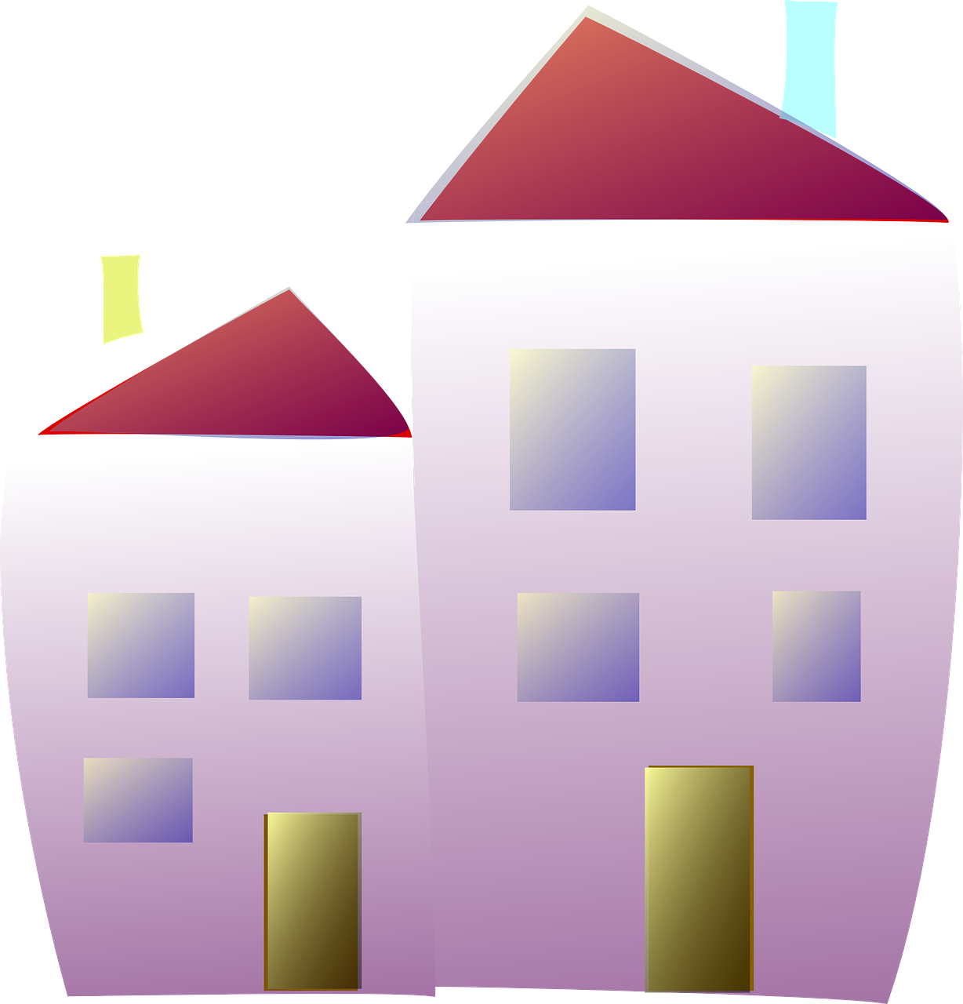
Learning outcomes
By the end of the lesson students will have:
- built on their knowledge of adjectives to describe neighbourhoods
- described their neighbourhoods
- developed their oral fluency and listening skills

Materials
Student’s handout / PPT
All images taken from Pixabay.com
Students to take a photo of their neighbourhood/ find a picture using Google Maps
Appendix 1 Word search (1.1: word search, 1.2: the adjectives and 1.3: the answers.)

Time | Procedure | Materials
5 minutes | - Display and clarify lesson objectives | PPT
10  minutes | - You are going to describe (a) local neighbourhood(s). To make your description more engaging, display images of the neighbourhood(s). As you describe them, ask students to make a note of the adjectives you use. Keep your adjectives deliberately simple e.g., rich, poor, safe, dangerous, clean, dirty, old, new, nice, horrible etc.  - Ask students to check their answers in pairs before conducting whole class feedback. If teaching online, stop your video and allow students to share the adjectives they heard without you being involved in the main room.  - Ask students what they think of the adjectives you used. Did they think they helped to give a good description? | PPT  Activity 1  Slide 1 images can be replaced with those of local neighbourhoods
15-20 minutes | - Explain that students are going to do a word search. They have to try and find 12 words to describe neighbourhoods. Depending on the group you may wish to create a greater challenge by not sharing the words with the students. Quiet has been given as an example. (The words are cosmopolitan, crowded, dull, unsafe, lively, popular, peaceful, noisy, quiet, run-down, rural, urban).  - Pair students/create breakout rooms for each pair of students and ask them to complete the word search. Encourage students to use online dictionaries to help them with words they don’t understand. Give the list of adjectives on page 2 Appendix 1.2 to students who need them.  - Once students have found all the words, ask them to discuss which adjectives they think are positive and which are negative. This is very subjective and should lead to an interesting discussion during feedback. To challenge stronger pairs, ask them to think of synonyms for the adjectives they found.  - Conduct whole class feedback together (in the main room if online). Display answers to the word search (Appendix 1.3). Check the meaning of words as necessary and focus on pronunciation.  - Ask students to share which adjectives they felt were positive and negative. Encourage students to justify their choices.  Explain that the adjectives could be considered positive or negative by different people. Encourage students to discuss how the way in which neighbourhoods are viewed/described could be the result of someone’s age, background, gender, culture, nationality etc.  - Possible synonyms to focus on if students did the extension activity: peaceful →calm; dull→boring; run-down→poor; cosmopolitan→multicultural; crowded→busy; unsafe→dangerous. | PPT  Activity 2  Appendix 1.1  (A4 word search)
20 minutes | - Tell students they are now going to describe their neighbourhoods (current or past) using some of the adjectives, ideally those that are new to them. If students have taken photos of their neighbourhood, ask them to have them ready to share. They can use Google Maps if they don’t have a photo.  - Give students time to think about their descriptions and their choice of adjectives. Monitor as necessary. If teaching online, you may want to allow students to stop their videos and mute themselves so they can concentrate on preparing for their descriptions.  - Then ask students to read through the questions they may want to answer when describing their neighbourhoods.  - Place students in small groups (recreate breakout rooms but this time place 3-4 students in each room) and ask them to take turns describing their neighbourhoods.  - Monitor. Make a note of their use of adjectives.  - Conduct delayed error and achievement feedback as a class / in the main meeting room. Focus on students’ use of the different adjectives. | PPT  Activity 3
5 minutes | - Conduct a plenary and ask students to choose the words in bold so the sentences reflect what they think. Encourage students to share their reflections. | PPT  Activity 4
Culture Describing Your Neighbourhood
Learning outcomes
By the end of the lesson, you will have:
- looked at different adjectives to describe neighbourhoods
- described different neighbourhoods and listened to descriptions of neighbourhoods
- discussed what makes a good neighbourhood

Activity 1: My neighbourhood
Listen to your teacher. As you listen, write down the adjectives you hear.

How many adjectives did you hear? Compare your adjectives with your partner. What do you think of the adjectives your teacher used?

Activity 2: Find the adjectives
There are 12 adjectives to describe neighbourhoods. How many can you find?
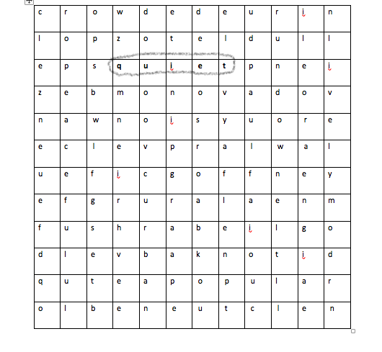
Look at the adjectives in the wordsearch. Which do you think are positive? Explain your answers.
Activity 3: Welcome to my neighbourhood
3.1 You are going to describe your neighbourhood to your group. Before you join your group, think about which adjectives you can use to give a good and honest description of your neighbourhood. Make a note of them here.

3.2 In your description, talk about what you see when you walk around your neighbourhood. Is it clean? Are there green spaces? Is it full of people or empty? Are the people from different backgrounds/cultures or from the same? Is it a new neighbourhood? Does it feel safe? How do you feel about living there? What do you think people who visit your neighbourhood for the first time will see? Make notes here.

3.3 Take turns in your groups to describe your neighbourhoods.

Activity 4: Reflection
Circle the words in bold in each sentence to make the sentences true for you.

People in my neighbourhood think positively/ negatively about our neighbourhood.
I can/ I can’t imagine living in another neighbourhood.
I’d like/ I wouldn’t like to see changes in my neighbourhood.
It is/ It isn’t my role to make my neighbourhood a better place.
Appendix 1.1
Enlarged version of the word search

c | r | o | w | d | e | d | e | u | r | i | n
l | o | p | z | o | t | e | l | d | u | l | l
e | p | s | q | u | 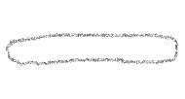  i | e | t | p | n | e | i
z | e | b | m | o | n | o | v | a | d | o | v
n | a | w | n | o | i | s | y | u | o | r | e
e | c | l | e | v | p | r | a | l | w | a | l
u | e | f | i | c | g | o | f | f | n | e | y
e | f | g | r | u | r | a | l | a | e | n | m
f | u | s | h | r | a | b | e | i | l | g | o
d | l | e | v | b | a | k | n | o | t | i | d
q | u | t | e | a | p | o | p | u | l | a | r
o | l | b | e | n | e | u | t | c | l | e | n

Appendix 1.2

List of adjectives to find

cosmopolitan | rural | lively
peaceful | rundown | dull
noisy | urban | popular
unsafe | crowded | quiet

Appendix 1.3
c | r | o | w | d | e | d | e | u | r | i | n
l | o | p | z | o | t | e | l | d | u | l | l
e | p | s | q | u | i | e | t | p | n | e | i
z | e | b | m | o | n | o | v | a | d | o | v
n | a | w | n | o | i | s | y | u | o | r | e
e | c | l | e | v | p | r | a | l | w | a | l
u | e | f | i | c | g | o | f | f | n | e | y
e | f | 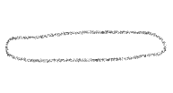  g | r | u | r | a | l | a | e | n | m
f | u | s | h | r | a | b | e | i | l | g | o
d | l | e | v | b | a | k | n | o | t | i | d
q | u | t | e | 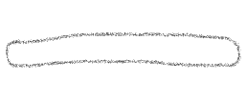  a | p | o | p | u | l | a | r
o | l | b | e | n | e | u | t | c | l | e | n

