Teachers’ notes Level B.1.1

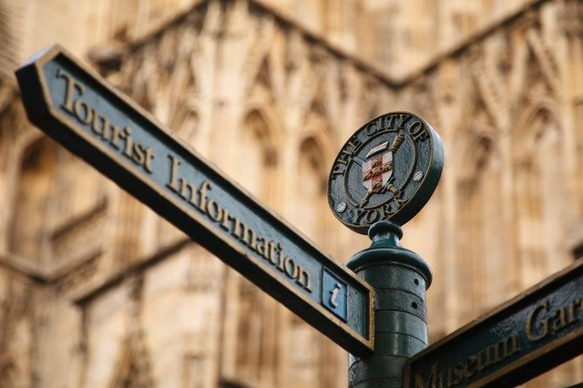
Lesson outcomes
By the end of the lesson students will have:

- discovered more about the town where you are now.
- practised map reading
- practised asking for and giving directions
- practised asking for information

Materials
Handout for students
Simple town maps (free from the local tourist office or town hall)
Appendices
PPT
All images taken from Pixabay.com

Time | Procedure | Materials
5 minutes | Activity 1: Brainstorm  - Display lesson objectives.  - Where can you go to meet people?  - Where can you go for information?  - Where can you go to buy more for less? | PPT
5 minutes  10 minutes  10 minutes  15 minutes  10 minutes | Activity 2a: Map reading  - Distribute local street maps, one between two, or use the town map on the PPT.  - Ask the pairs to find key places. Set a time limit for this of 3 minutes.  Suggested key places:  The railway station The bus station The post office The church/cathedral The local government offices (Council offices, City Hall or Town Hall) The shopping centre The parks The central square or market square The tourist information office The library.  Activity 2b: Giving directions in town.  - Look together at Phrases 1 in the language box.  - Give students a starting point, a station or the school.  - Do 2 or 3 examples together.  - Continue in pairs.  Activity 2c: Giving directions from here to there. Asking and answering.  - Look at Phrases 2 in the language box  - Ask students to give directions from one key place on the town map to another.  - Do some examples together. This time answers must be detailed.  - Continue in pairs.  Activity 3: Card game  - Ask students what they can do at each of the key places.  eg. buy a ticket (station), buy stamps (post office), ask information(tourist information office), attend a service (church)  - Give them time to check the language box again  - Put the pairs into 4’s  - Distribute cards for the groups of students to look at.  - Place the cards face down in the centre of the table.  - One student takes a card and asks directions to another student, who answers giving clear directions.  - The card is then put to the bottom of the pile.  - The second student then takes a card and asks directions.  Variation: Swap the groups of cards around after 5 minutes and continue.  Activity 4: Whole class feedback  - Each group demonstrates an example dialogue to the others.
5 minutes | Activity 5: Reflection  - How has this lesson helped students to get around and find out about where they are living?  - Will they feel more confident about asking directions and asking information to people in the street?

Students’ handout

Lesson Outcomes
By the end of the lesson you will have:
- discovered more about the town where you are living.
- practised map reading
- practised asking for information
- practised asking for and giving directions
Activity 1: Discussion
- Where can you go to meet people?
- Where can you go for information?
- Are there thrift stores and discount stores?
Activity 2a: Map Reading
- Look at a local street map, or use the town map on the PPT.
- Find some key places. Check all together.
Activity 2b: Giving Directions in town
- Look together at Phrases 1 in the language box.
- Choose a starting point. eg. a station or the school.
- Do 2 or 3 examples together.
- Continue in pairs.
Activity 2c: Giving directions from here to there. Asking and answering
- Look at Phrases 2 in the language box
- Practice giving directions from one key place on the town map to another.
- Do some examples together. This time answers must be detailed.
- Continue in pairs.
Activity 3: Card Game
- What can we do at each of the key places?
eg. buy a ticket (station), buy stamps (post office), ask information (tourist information office), attend a service (church)
- Check the language box and Appendix 1
- Get into groups of 4. Your teacher will give you some cards. Look at the town map.
- Put the cards face down in the centre of the table.
- One of you takes a card and asks a question to another, who answers giving clear directions.
- The card is then put to the bottom of the pile.
- The second person takes a card and the question and answer continues.
Activity 4: Whole class feedback
- Each group demonstrates an example dialogue to the others.
Activity 5: Reflection
- How has this lesson helped you to get around and find out about where you are living?
- Will you feel more confident about asking directions and asking information to people in the street?

Language Box: Giving Directions
Phrases 1 Activity 2b Giving Directions.
- eg. Where is the post office? (Next to the florist’s)
- Where is the Town Hall? ( At the end of the central shopping street, near the river)
- Excuse me, here is the street market? (in the town square, opposite the cathedral)
Phrases 2 Activity 2c Getting from here to there
- eg. How can I get to the post office? (Carry on along this road and turn left at the end. Go straight on at the roundabout until you reach the town centre, about 500 meters. The post office is next to the florist’s on the right)
- eg. Excuse me, I’m looking for the Town Hall? (Walk through the town centre and along the main shopping street. The Town Hall is the building at the end just before you go down to the river.)
Notice: Giving landmarks can help the person receiving the directions.
- eg:…turn right just after the Esso garage ….. when you see the Tesco superstore on the left, the market is just behind it ….
- eg. …. Drive TO the end of the street, but turn right AT the end of the street
Notice: Verbs and phrasal verbs used in giving directions often include the verb TURN:
- eg. turn RIGHT, turn LEFT, turn INTO (Station Street), turn ONTO the bypass, turn ROUND at the end of the road.
- eg …. Turn INTO the garage, but turn ROUND (when you do a U turn).
Notice: We CROSS (verb) the road or go/walk/run ACROSS (verb + adverb) the road.
Glossary: Some cultural information to notice:
- Some road features may be new to you: roundabouts, underpasses, zebra crossings and traffic lights with the red AMBER and green lights.
- Cycle paths may be new too, the compulsory lighting on a bicycle at night and the importance too, of wearing a high visibility jacket (high viz jacket/vest) or fluorescent jacket, while riding a bicycle

Appendix 1 (For the card game) Asking about a place:
- Excuse me, where is ….. please?
- Excuse me, how can I get to ……..?
- Do you know where the nearest (chemist’s) is, please?
- I’m looking for ……
- Could you tell me where the (nearest chemist’s) is please?_
For the card game. Key places in town:
the bank
the barber’s/the hairdresser’s
the centre of town
The town/city hall
the exchange office
the library
the hospital
the chemist’s/pharmacy
the street market
the park
the train/ railway station
the bus station
The police station
The church
The church hall

Example answers:
- The chemist’s is along the High Street between the supermarket and the newsagent’s.
- Well from here, carry on walking into the centre. All the shops are along the High Street. The chemist’s is just after the supermarket.
- Yes of course. The nearest one is in the High Street just after the supermarket.
Use prepositions of place:
On, in, near, next to, between, in front of, behind, along, past, just after/just past, opposite.
a landmark is a useful point of reference:
eg. : in front of the car park, just past the café’, next to the supermarket.

