Teachers’ notes Level B1.2

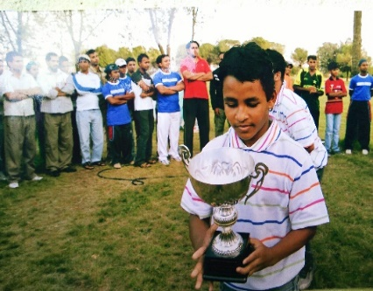
Lesson outcomes
By the end of the lesson students will have:
- listened to one of the organisers.
- understood how to organise successfully a cricket tournament.
- become aware of special requirements.
- used the same idea with a different sport.

Materials
Handout for students, Appendix, PPT

Time | Procedure | Materials
5  minutes | Activity 1: Introductory discussion  - Display lesson objectives.  - Does anyone know about cricket, how to play it and any of the rules of the game?  - Which countries have a national cricket team? | PPT
15 minutes  10 minutes  10 minutes  15 minutes | Activity 2: Background  - The idea featured in this lesson brings together different cricketing nations in a friendly tournament.  - Ask students to listen to Tanveer and take notes about this idea.  - Put the students into groups to discuss together what Tanveer said. They can listen again if they ask to.  Activity 3: Comprehension check  - Ask a few questions: Where can people play cricket? What is essential? What was special about the Bangladeshi supporters?  - Ask students to work in pairs to complete the 6 multiple choice questions on the ppt. Go through the answers all together.  - One essential requirement for this tournament was to have plenty of: a) time b) space c) players d) light  - If you organise a tournament in a public place you must have: a) verbal authorisation b) written permission c) a spoken agreement d) verbal permission  - A cricket team usually has 11 players. How many players per team did Tanveer decide to have in this tournament? a) 15 b) 10 c) 8 d) we don’t know  - A cricket match can take a long time. How long did each of these matches last? a) 30 minutes b) 50 minutes c) one hour d) one and a half hours.  - The Bangladeshi supporters were: a) noisy b) colourful and enthusiastic c) hungry and thirsty d) noisy and indisciplined.  - What was the pleasant surprise? a) Tanveer’s team won b) one of the teams was mixed (both men and women) c) some teams were colourful d) some of the supporters cooked food  Answers: 1.b 2.b 3.c 4.c 5.b 6.d  Activity 4: Activity worksheet  - Tell students to check the language box. Give out the worksheet (Appendix 1) to complete in pairs. Go through the answers all together.  Answers:  - Fill the gap. Complete the sentences from Tanveer’s spoken description of the cricket tournament:  - Because you need quite a lot of space to play cricket, we had to find a place to HOLD the tournament.  - Normally, cricket matches LAST quite a long time.  - I was lucky because I had a friend on the local COUNCIL Who was able to ask the OWNER If we could play there.  - I decided to create a new type of tournament with 8 players INSTEAD OF 11.  - True or false?  - Each match was one hour long. True False  - The Bangladeshis came along with a lot of supporters, mainly children. True False  - The Bangladeshi supporters prepared curry and rice for everyone. True False  Activity 5: Organise a tournament.  - In groups, students choose a different team sport and prepare a similar tournament making appropriate variations if necessary.  - Briefly listen to what each group has prepared.
5 minutes | Reflection: Discuss all together  - Is sport an effective way to encourage friendship and integration?  - Do students think this idea could work the same with a mixed team or a women’s team?  - Which other team sport would create a good tournament for promoting teamwork and making friends?
Students’ handout
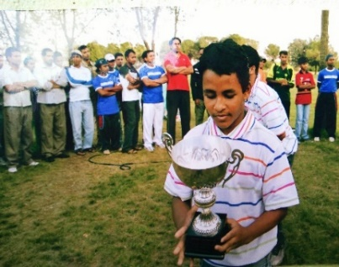
Lesson Outcomes
By the end of the lesson you will have:
- listened to one of the organisers.
- understood how to organise successfully a cricket tournament.
- become aware of special requirements.
- used the same idea with a different sport.

Activity 1: Introductory discussion.
- Does anyone know about cricket, how to play it and any of the rules of the game?
- Which countries have a national cricket teams?
Activity 2: Background
- The idea in this lesson is to bring together different cricketing nations in a friendly tournament.
- Listen to Tanveer and take notes about this idea.
- In groups or pairs, discuss together what Tanveer said.
- Listen again if you want to.
Activity 3: Comprehension Check.
- Where can people play cricket? What is essential? What was special about the Bangladeshi supporters?
- Work in pairs to complete the 6 multiple choice questions below and on the ppt. Go through the answers all together.
- One essential requirement for this tournament was to have plenty of: a) time b) space c) players d) light
- If you organise a tournament in a public place you must have: a) verbal authorisation b) written permission c) a spoken agreement d) verbal permission
- A cricket team usually has 11 players. How many players per team did Tanveer decide to have in this tournament? a) 15 b) 10 c) 8 d) we don’t know
- A cricket match can take a long time. How long did each of these matches last? a) 30 minutes b) 50 minutes c) one hour d) one and a half hours.
- The Bangladeshi supporters were: a) noisy b) colourful and enthusiastic c) hungry and thirsty d) noisy and indisciplined.
- What was the pleasant surprise? a) Tanveer’s team won b) one of the teams was mixed (both men and women) c) some teams were colourful d) some of the supporters cooked food.

Activity 4: Activity Worksheet
Look at the language box.
- Now complete the worksheet (Appendix 1) in pairs.
- Go through the answers all together.
Activity 5: Organise a tournament.
- In groups, choose a different team sport and prepare a similar tournament making appropriate variations if necessary.
- All together, briefly listen to each other’s ideas.
Reflection: Discuss all together:
- Is sport an effective way to encourage friendship and integration? Why? Why not?
- Cricket is best known as a man’s sport, but do you think this idea could work the same with a mixed team or a women’s team?
- Which other team sport would create a good tournament for promoting teamwork and making friends?

Language Box:
- Mitigator: Quite
When we want to make an adjective less strong, we use quite (or rather). In Tanveer’s speech, he says,
Eg. “ … cricket matches last quite a long time.” (They are long but not very long).
Eg. 2 “You need quite a lot of space ….” (You need a lot of space but not an enormous quantity).

- Intensifier: Quite
Used with strong adjectives or extreme adjectives, quite (really or absolutely) strengthens the meaning to absolutely. Intonation is also very important here.
Eg. “The guacamole tasted quite awful”. (It was much too salty).
Eg2. “The weather was quite terrible” - wet, cold, windy!! (the weather was absolutely terrible).

Appendix 1
Activity worksheet
- Fill the gap. Complete the sentences from Tanveer’s spoken description of the cricket tournament:
- Because you need quite a lot of space to play cricket, we had to find a place to ……………... the tournament.
- Normally, cricket matches ……………………….. quite a long time.
- I was lucky because I had a friend on the local ……………………………………. who was able to ask the ………………………. If we could play there.
- I decided to create a new type of tournament with 8 players ………………………………. 11.
- True or false?
- Each match was one hour long. True False
- The Bangladeshis came along with a lot of supporters, mainly children. True False
- The Bangladeshi supporters prepared curry and rice for everyone. True False

- Mitigators: Quite (or rather)
When we want to make an adjective less strong, we use quite (or rather). In Tanveer’s speech, he says,
Eg. “ … cricket matches last quite a long time.” (They are long but not very long).
Eg. 2 “You need quite a lot of space ….” (You need a lot of space but not an enormous quantity).
Complete the following sentences with a mitigator, quite (or rather):
- The teacher was having …………………………. a tiring day.
- My brother is ………………………. good at football, but not good enough to play professionally.
- Her white dress was …………………………. pretty, but blue suits her more.
- The film lasted ……………………………… a long time.

- Intensifiers: Quite (or really) with strong adjectives or extreme adjectives, strengthens the meaning to absolutely. Intonation is also very important here.
Eg. “The pasta sauce tasted quite awful”. (It was much too salty).
Eg2. “The weather was quite terrible - wet, cold, windy!!” (the weather was absolutely terrible).
Try to complete these sentences using quite the sense of absolutely, choose from these adjectives: boring, wonderful, disturbing, sad, magical, exciting, incredible, amazing, freezing, gorgeous,excellent.
- The music …………………………………………………………………………………………………………………………..
- The singer ……………………………………………………………………………………………………………………………
- The match …………………………………………………………………………………………………………………………..
- The performance ……………………………………………………………………………………………………………….
- The sea ……………………………………………………………………………………………………………………………….

