Teachers’ notes
Diversity Types of Discrimination B1.2
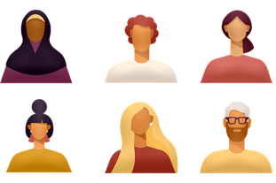
Learning outcomes
By the end of the lesson students will have:
- thought about whether they judge people by their appearance
- focused on the vocabulary used to talk about different types of discrimination
- looked at some case studies to decide whether the people are being discriminated against

Materials
Student’s handout / PPT
All images taken from Pixabay.com
Appendix 1: images of different people

Time | Procedure | Materials
5 mins | - Display and clarify learning outcomes. | PPT
10-15 minutes | - Ask students to think about a recent journey they took on public transport. How did they decide where to sit? Did they look at the other passengers and make a decision about who to sit near?  - Explain that they are going to look at some photos of people and make judgements about the people by looking at the photos. Do an example e.g. who would you like as a neighbour? Explore why they would/wouldn’t like certain people as neighbours using the language in the language box.  - Give them a couple of minutes to look on their own then put them into pairs / create breakout rooms to discuss further.  - Conduct whole class feedback and introduce the idea of judging people by their appearance. Talk about how we have preconceived ideas of people based on their identities, or hairstyles, clothes, whether they have tattoos etc. | PPT  Activity 1
10-15 minutes | - Either keep students in the same pairs or change them to different pairs and tell them they are going to choose the best word to complete the sentences. Suggest that whilst they are doing the activity, they might also want to discuss some of the statements. Before students do the activity check their understanding of ‘to come out’ and ‘graffiti.’  - Conduct whole class feedback focusing on all aspects of the vocabulary (meaning, pronunciation and form (noun or adjective). Also note any dependent prepositions e.g. ‘discriminate against.’ Highlight the fact that some of the vocabulary items focus on specific forms of discrimination e.g. racism, homophobia etc whilst others are general terms e.g. discrimination, prejudice.  [Answers:  1. The police have been accused of racism because they stop and search more people of colour than white people.  2. She had to battle for a long time against the prejudice towards the idea of women being pilots. But now she is a fully qualified pilot!  3. Zaidi believes the company he works for is ageist because any promotions in the company are always given to the younger members of the team.  4. Ching recently came out on Instagram and since then she’s received a lot of unkind comments about being gay. She’s been really upset and surprised by the homophobic reaction of people she knows.  5. Immigrants are often discriminated against when they apply for jobs.  6. It’s totally sexist to say women are better than men at looking after children.  7. Since 9:11 there has definitely been an increase in Islamophobia  8. There have recently been some attacks on Jewish graveyards. Graves have been vandalised with anti-Semitic graffiti. ] | PPT  Activity 2
20 + minutes | - Tell students they are going to look at situations in which people believe they are being discriminated against or are possibly being discriminatory themselves. Explain that they need to decide whether or not they agree with what the people say and justify their thinking. Check understanding of the word ‘Sabbath’ before they start to do the activity.  - Give students a couple of minutes to look on their own then put them into small groups / create breakout rooms to discuss each situation.  - Conduct whole class feedback. | PPT  Activity 3
5 minutes | - Tell students you want them to reflect on this lesson and decide which of the statements they believe is true for them. The purpose of this discussion is to explore where our prejudices come from. Also make the point that everyone has prejudices but it is important to recognise them so you don’t let them get in the way of any decisions you make. | PPT  Activity 4

Diversity Types of Discrimination
Learning outcomes
By the end of the lesson, you will have:
- thought about whether you judge people by their appearance
- focused on the vocabulary used to talk about different types of discrimination
- looked at some case studies to decide whether the people are being discriminated against
Activity 1: Who would you …?
Look at the photos of different people and decide who you would and wouldn’t …
like as a neighbour want to be your friend
want to share a taxi with want to be your doctor
want to be your teacher want to sit next to on public transport
Discuss your answers with a partner. Use the language in the language box to tell your partner how you made your decision.

Language Box: Describing people
S/he looks / might be [a bit/ quite / very] + adj
I think s/he would be a bit/ quite / very] + adj
I’d worry that s/he might + bare inf.
I don’t think we’d get on / s/he’d be a good teacher etc. because …

Activity 2: What is discrimination?
Circle the correct word.

1. The police have been accused of racism / racist because they stop and search more people of colour than white people.

2. She had to battle for a long time against the prejudice / prejudiced towards the idea of women being pilots. But now she is a fully qualified pilot!

3. Zaidi believes the company he works for is ageism / ageist because any promotions in the company are always given to the younger members of the team.

4. Ching recently came out on Instagram and since then she’s received a lot of unkind comments about being gay. She’s been really upset and surprised by the homophobic / homophobia reaction of people she knows.

5. Immigrants are often discrimination / discriminated against when they apply for jobs.

6. It’s totally sexist / sexism to say women are better than men at looking after children.

7. Since 9:11 there has definitely been an increase in Islamophobia / Islamophobic.

8. There have recently been some attacks on Jewish graveyards. Graves have been vandalised with anti-Semitic / anti- Semitism graffiti.
Activity 3: Discrimination?
Read the situations in which people are unhappy. Tick to what extent you agree with what they say. Why? Why not? Are they being discriminated against or being discriminatory themselves? Do you think there is any justification for anything they say?

Zamir “I recently went to see a doctor and was quite upset to find it was a woman. In fact, I refused to see her and rebooked the appointment so I could see a man. I think it’s really important to be able to choose the gender of the doctor you see.”
Agree strongly | Agree | Disagree | Disagree strongly

Lila “We’ve been visiting local schools recently to find a primary school for our young daughter. One of things we’ve particularly noticed is that a lot of the primary school teachers here are young males. I don’t like the idea of my daughter being taught by a youngish man.”
Agree strongly | Agree | Disagree | Disagree strongly

Joshua “I’ve just got a job working in a supermarket. I accepted the job but said I couldn’t work any Friday night or Saturdays because it’s the Jewish sabbath. I’ve been told they won’t employ if I am not available every day. I think that’s it’s anti-Semitic.”
Agree strongly | Agree | Disagree | Disagree strongly

Jamal “My elderly father from Pakistan needs someone to come in a care for him whilst we are at work. I applied to an agency and they sent a young man from Estonia. I’ve said, they have to send someone from the same background so they can understand each other.”
Agree strongly | Agree | Disagree | Disagree strongly

Dalia “I’m pregnant and recently went for promotion at work. They told me they wouldn’t offer me the position because I’m pregnant. I think that’s really unfair.”
Agree strongly | Agree | Disagree | Disagree strongly

Gloria “My family and I are looking for a bigger place to rent. I’m in a wheelchair. We saw a place yesterday that was perfect but the landlord said it wasn’t suitable for anyone in a wheelchair so he wouldn’t rent it to us.”
Agree strongly | Agree | Disagree | Disagree strongly

Franco “I’m quite worried about my 6-year-old son. He’s only interested in playing with girls and wants to play with dolls. I think he might be gay and I don’t want a gay son.”
Agree strongly | Agree | Disagree | Disagree strongly
Compare your responses with your classmates.

Activity 4: Reflection
Are the statements true or false for you?
I sometimes judge people on their appearance without knowing anything about them.
I think I do have some prejudices because of my background.
My views towards different groups of people are different to the views of my family.
There is a lot of discrimination where I live now.
People accept differences more now than in the past.

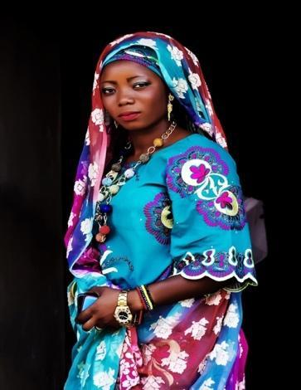
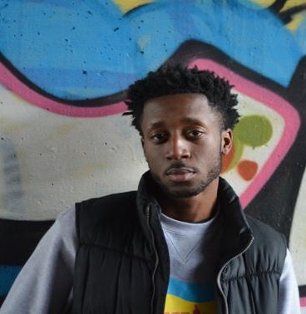
Appendix 1
 | 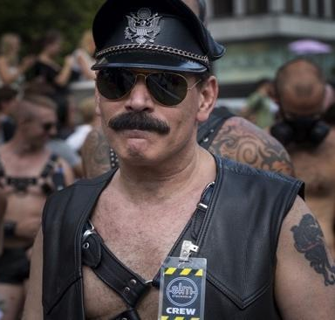 | 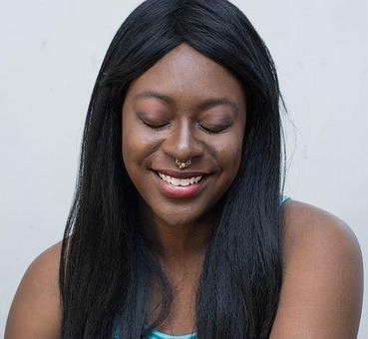
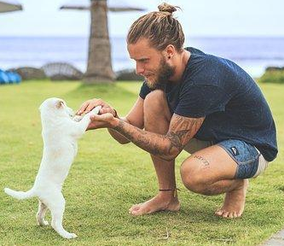 | 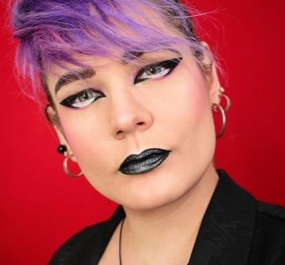 | 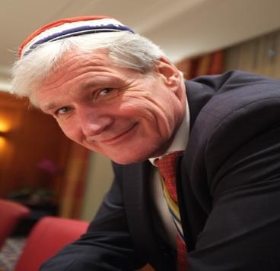
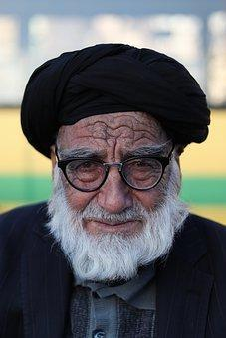 | 