Teachers’ notes Level B1.2

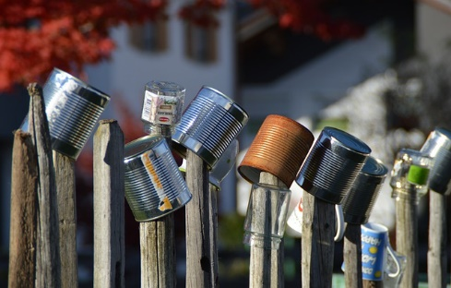
Lesson outcomes
By the end of the lesson students will have:
- Read about and understood the advantages of recycling and reusing.
- Practised quantities and the pronunciation of quantities.

Materials
Handout for students
Appendices
PPT
All images taken from Pixabay.com

Time | Procedure | Materials
5 minutes | Activity 1: Introductory discussion  - Display and clarify lesson objectives.  - Introductory discussion: What did students always/never/usually sometimes reuse or recycle where they lived before?  - Who organised collections of recyclable waste?  - Do charities in their countries organise collections of recyclables? | PPT
10 minutes  15 minutes  20 minutes | Activity 2 : Let’s Break it Down  - What can we recycle and reuse?  Elicit groups of recyclables: paper, metal, glass, plastic, textiles, organic waste, medicines and tablets, spectacles, batteries, shoes, tyres, oil and household hazardous waste (paints, pesticides, cleaning products, oils), mobile phones and computers for example.  - Hand out or display Leaflet B “Let’s Break it down”.  - Call out a number or quantity on the leaflet. Students call out the material referred to – paper, plastic etc  Eg. 80% of people second hand clothes/textiles  Eg. 17 trees paper  Activity 3: Look at the Glossary  - Listen to the pronunciation of the numbers on the leaflet, percentages and fractions  - Pairwork, students practise the pronunciation.  - Pairwork. Students do worksheet 1.  - Go through the answers together.  Answers:  3 hours of TV power METAL  25 2 litre bottles PLASTIC  500,000 (half a million) PAPER  80% TEXTILES/CLOTHES  25 minutes GLASS  4 days GLASS  60 watt light bulb PLASTIC  17 trees PAPER  Activity 4: Pairwork  - Briefly refer to much and many in the language box.  - Worksheet 2. Complete the questions with How much? or How many?  - Find the answers in Leaflet B.  - Go through the answers together  Answers:  How much …….. ?  how many ……...?  …plastic bottles do we need to make an adult sized fleece? 25 2 lt bottles  ... hours of energy can be saved by recycling one aluminium can? 3 hours of television power time  ... years does it take for plastic to decompose? 500 years  … people in Africa, according to the leaflet, wear second-hand clothes? 80 %  ... trees a year are saved by recycling paper? Nearly half a million  ... energy is saved by recycling one glass bottle? Enough to power a computer for 25 minutes  ….. glass is recycled in the county of Devon every year?  Enough to power a computer for every resident in Devon for 4 days  ….. trees are saved by recycling 1 tonne of paper? 17  ….. clothes are re-used and how many are made into textiles?  - 50% reused and 50% made into textiles  ….. of all newspapers are made from recycled paper? 100%
10 minutes | Reflection  Allow students to make notes before starting this speaking activity.  - How do people recycle in their country? How is recycling organised? What is recycled? What is thrown away?  - Compare recycling in this country and in one other country.  - What other ways are there to recycle? What is their experience?  - What are the advantages of recycling and reusing?  - How important is it to reduce waste? Why?  - How will they now try to recycle more?
Students’ handout

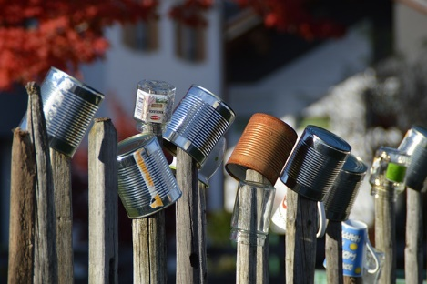
Lesson Outcomes
By the end of the lesson you will have:
- Read about and understood the advantages of recycling and reusing.
- Practised quantities and the pronunciation of quantities.

Activity 1 : Introductory discussion:
- What did you always/never/usually sometimes reuse or recycle where you lived before?
- Who organised collections of recyclable waste?
- Are there charities that organise collections of recyclables?

Activity 2: “Let’s break it down!”
- What can we recycle and reuse? Eg. batteries, plastics ….. Introductory discussion.
- Look at leaflet “Let’s Break it Down” Appendix 1. Look quickly for the material in each coloured section of your handout – paper, glass, plastic etc eg: in the green section it is glass.
- Your teacher will call out a quantity. Find the quantity and decide if it is referred to glass, paper, plastic, textiles or metal.

Activity 3: Look at the glossary.
- Listen to the pronunciation of the numbers on leaflet B, percentages and fractions
- Pairwork, students practise the pronunciation.

Activity 4 : Matching and writing
- How much recyclable material is there in each coloured section of “Let’s Break it Down?”
for example: 1 glass bottle
- Read each section to find out what we can do with the energy we save.
for example: power a computer for 25 minutes
- Worksheet 1 Appendix 2. Match the quantity and the saving.

Look at the language box: Quantities.
- Worksheet 2 Appendix 3. In pairs, complete the questions with How much? or How many? and then answer the questions. Go over the answers with your teacher.
Reflection:
Make some notes before you start speaking:
- How did people recycle where you lived before? How is recycling organised? What is recycled? What is thrown away?
- Compare recycling in this country and in another country.
- What other ways are there to recycle and reuse? What is your experience?
- What are the advantages of recycling and reusing?
- How important is it to reduce waste? Why?
- How will you now try to recycle more?

Language Box

Quantities
Much = uncountable quantity, singular verb, neg or interrog eg. paper, glass, energy
Many = countable quantity, plural verb, neg and interrog eg. newspapers, glasses, people
Use A lot of or lots of in the affirmative sentences. Eg. A lot ot paper, a lot of newsapers
Eg. Lots of paper, lots of newspapers

Glossary
Saying quantities: % = percent eg. 10% = ten percent, 50% = fifty percent

Fractions: eg. ½ = half, ¼ = a quarter, three-quarters, one fifth, three fifths

Decimals: 1.5 = one point five, 6.25 = six point two five

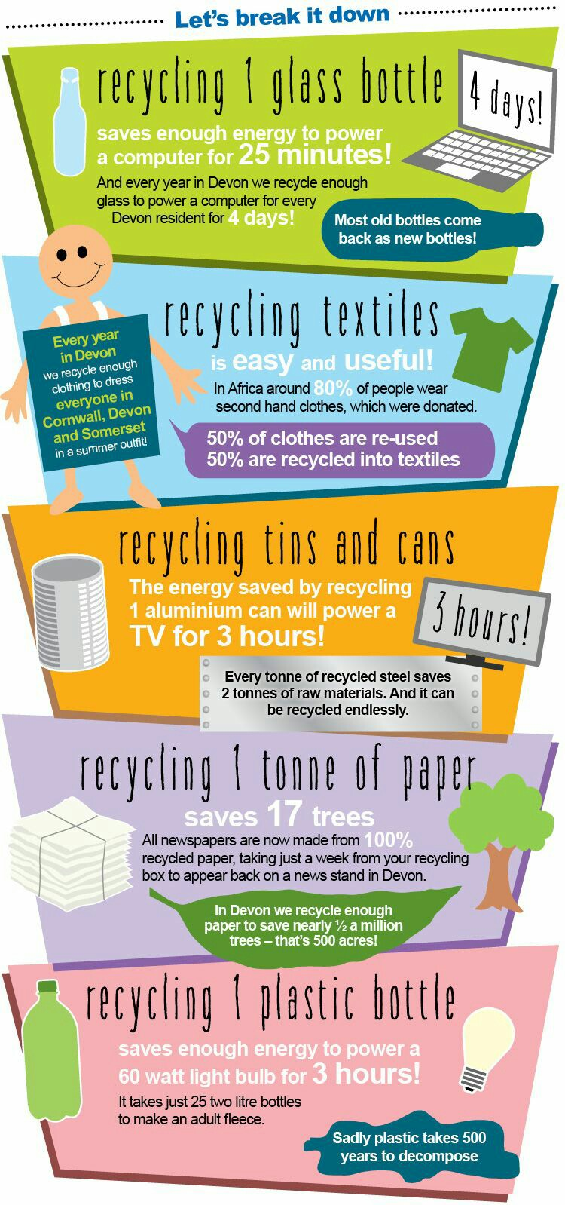
Appendix 1: “Let’s Break it Down”

Appendix 2

Worksheet 1: Match the quantity and the material.

Eg. 3 hours of TV power = metal (1 aluminium can)

Glass
Metal
Paper
Plastic
Textiles or clothes

Appendix 3

Worksheet 2: Complete each question with How much? or How many? and find the answers in leaflet B “Let’s Break it Down!”

How much …….. ?
how many ……...?

Eg. How many …. plastic bottles do we need to make an adult sized fleece (a soft, hooded zipped jacket)? We need one bottle!

1.………………... plastic bottles do we need to make an adult sized fleece?
2.………………... hours of energy can be saved by recycling one aluminium can?
3………………... years does it take for plastic to decompose?
4………………… people in Africa, according to the leaflet, wear second-hand clothes?
5.………………... trees a year are saved in Devon by recycling paper?
6.………………... energy is saved by recycling one glass bottle?
7.………………... glass is recycled in Devon every year?
8.………………... trees are saved by recycling 1 tonne of paper?
9.………………... clothes are re-used and how many are made into textiles?
10………………... of a newspaper is made from recycled paper?

