Teachers’ notes
Diversity Identity B1.1
Learning outcomes
By the end of the lesson students will have:
- practised describing people and making notes
- listened to people talking about their identity
- considered their own identity and how it compares to how others view them

Materials
Student’s handout / PPT
Appendix 1 Audio script Appendix 2 - 2 sets of photos
All images taken from Pixabay.com

Time | Procedure | Materials
5 mins | - Display and clarify learning outcomes. | PPT
15 minutes | - Tell students you are going to give them a set of photos. They need to choose one person in their set to describe to their partner. There are 2 sets of photos in Appendix 1.  - Before placing students in pairs, distribute sets and allow them time to make notes on their descriptions. Monitor and offer support as necessary. Avoid reviewing ways of describing people as this may restrict students in what they focus on in their descriptions.  - Pair students and ask them to each give their description. As they listen to each other’s descriptions they need to make notes. Students then reflect on the information they included in their descriptions.  - Conduct whole class feedback and elicit what was focused on in their descriptions. Make the link to then talking about identity and how challenging it can be to explain our identity to others. Elicit what students think identity is. For example, do they feel is it connected to a person’s beliefs, personality, profession, social or cultural background, or all of these? | PPT  Activity 1
15 minutes | - Tell students they are going to listen to an extract of a radio programme on identity.  - Go through the words in the first listening task and check students' understanding of gender and sexuality. There is a glossary after Activity 3 which you may wish to add to.  - Play the audio and ask students to circle what the speakers mention when talking about their identity. Before checking as a class allow students to compare their answers with each other [Suggested answers: Age, gender, nationality, profession, sexuality, religion, colour of skin/race, other -physical mobility/ disability, hair].  - Set the second task. Play the audio again. Allow students time to compare their answers before conducting whole class feedback. [Answers: 1. Liam 2. Fahad 3. Liam/ the host 4. Eve 5. Liam/ Eve 6. Liam]. | PPT  Activity 2
10 minutes | - Tell students they are going to discuss their identity and think about what is key to who they are. Consider giving an example about your identity. You could then elicit how your students see you and see how similar or different their view of you is to your view of yourself.  - Allow students time to think and add words to each circle. Monitor and offer support as necessary. Refer students to words in the glossary. You may wish to add to the glossary depending on who is in your group.  - Place students in small groups and encourage them to share how they see themselves and compare this to how others in the group see them.  - Conduct brief whole class feedback. | PPT  Activity 3
5 minutes | - Conduct a plenary and ask students to discuss the questions. Focus on how identity can change and how sometimes people who find themselves in a new country, town or village may notice their identity changes with time or how they see others changes. What we think is important in terms of identity might change. | PPT  Activity 4

Diversity Identity
Learning outcomes
By the end of the lesson, you will have:
- practised describing people and making notes
- listened to people talking about their identity
- considered your own identity and how it compares to how others view you

Activity 1 Describing a Photograph
Look at the set of photos from your teacher. You are going to describe one person. Choose who you want to describe and make some notes below to help you with your description.
____________________________________________________________________________________________________________________________________________________________________________________________________________________________________________________________________________________________________________________________________________________________________________________________________________________________________________________________________________________________

Describe your picture.

Listen to your partner’s description. Make notes as you listen.
____________________________________________________________________________________________________________________________________________________________________________________________________________________________________________________________________________________________________________________________________________________________________________________________________________________________________________________________________________________________

Show each other your set of pictures. What do you think of each other’s descriptions?
What information did you include in your descriptions? Why do you think you did this?

Activity 2 Who I am
2.1 Listen to the radio programme. Which of the following do the speakers mention when discussing their identity?

Age Gender Nationality Personality Profession

Religion Race Sexuality Social Background

Skin Colour Other

2.2 Listen again and circle the correct answer.

- Who is most proud of their family background? Fahad/Eve/ Liam/the host
- Who would rather not talk about their country of origin? Fahad/Eve/ Liam/the host
- Who doesn’t mention their gender? Fahad/Eve/ Liam/ the host
- Who feels that the importance they attach to their identity now has been influenced by their past? Fahad/Eve/ Liam/ the host
- Who talks about their physical appearance? Fahad/Eve/ Liam/ the host
- Who mentions a disability? Fahad/Eve/ Liam/ the host

Activity 3 How I see myself and how I think you see me

3.1 You are going to discuss your identity with your group. Before you do, think about
how you see yourself. When you look in the mirror what do you see? How do you think others see you? Make a note of a few key words.
ME
ME

How I see myself How I think others see me
3.2 Tell your group about how you see yourself and ask them how they see you. How similar were your views of each other?

Glossary: Identity
gender fluid: a person whose gender changes over time
non- binary: a person who chooses not to be identified as either male or female
Caucasian: a formal way of describing someone who is white
of colour: a phrase used to describe someone who is not white
an atheist: a person who does not believe that god exists

Activity 4: Reflection
Discuss the following questions.

Which aspects of identity are important to you? Why?
Why might people want to change some aspects of their identity?
Which aspects of a person’s identity might change as a result of living in a different country?

Appendix 1
Audio script (to be recorded)
Hi Fahad.
Thank you for agreeing to come onto today’s show to talk about identity. We’re exploring how people view themselves and finding out what is important to them when talking about who they are and of course how others see them too.

Hi Gianni. You want to tell you about my identity? Well to start with I am not originally from the .... but I’ve been living and working here now for almost 12 years. This is often one of the first questions I’m asked when I see patients in the hospital where I work. To be honest I find that really annoying. I’m a doctor and that for me is key to my identity... as is being a Muslim, a loyal husband and a dedicated father.

Thanks very much Fahad. It’s interesting that people often ask you where you are from. Is that not important to you?

Yes of course it is but when it’s the first question people ask you at work or socially, I often pretend not to hear and change the subject.

Thank you, Fahad, now let’s hear what Eve has to say about her identity

Hi Gianni. It’s interesting to hear Farhad talking about people asking him where’s from as I think I do
that a lot especially when I’m socialising or networking.

Well for me the key thing about my identity is my sexual orientation. I’m a lesbian.
This isn’t something I go around telling everyone I meet but it is very important to me probably because I wasn’t able to openly share this when I was younger. It’s not something I ask other people about unless it comes up in conversation. I’m not religious so that isn’t key to my identity. I think that’s it really oh and my age of course. I’m a woman of a certain age! In other words, I’m not young! That’s the first thing I’m sure people see when they meet me. I try to ignore my wrinkles when I look in the mirror but yes age is key to my identity.

Thanks Eve. You know what they say about age! You’re as young as you feel! Finally let’s move onto our third and last guest before the news at midday- Liam. Hello Liam, are you there?

I certainly am Gianni! Thanks for inviting me onto the show. Well, I think nowadays one of things people often feel is important to them is the colour of their skin. I’m mixed race so people are often surprised when they see me as my name is Liam O’Doherty. It’s a typically Irish name. We have a wonderful family history so my name especially my surname is key to who I am as well as my mixed heritage... apart from that what else can I say about my identity. I’m not as physically mobile as many other people and can only walk with support and that could well be the first thing people I meet for the first time notice about me. Err... what else I’m Catholic but I don’t practice so that’s not important to me. Ahh yes, I’m bald and really identify with other bald men. It’s quite funny when I meet someone else who is bald as I immediately feel a bond with them!

Thank you Liam. It’s interesting what you say about your appearance as my wife has ginger hair and she feels a real bond with other red heads. .... ( fade out) from our guests today we can see that identify means different things to different people....
Appendix 2
SET A
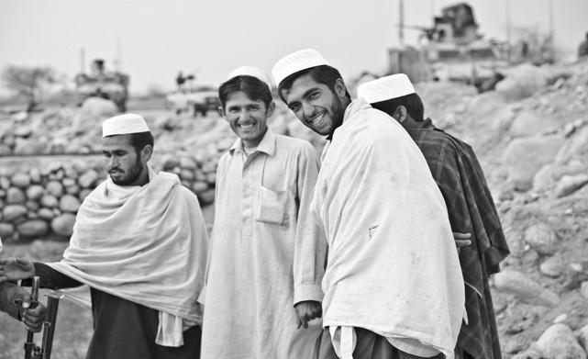
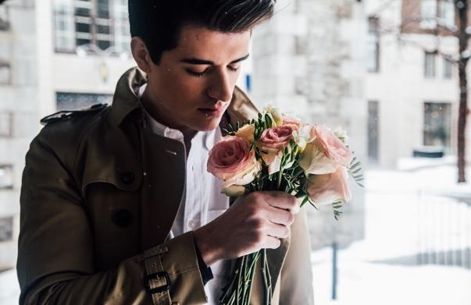

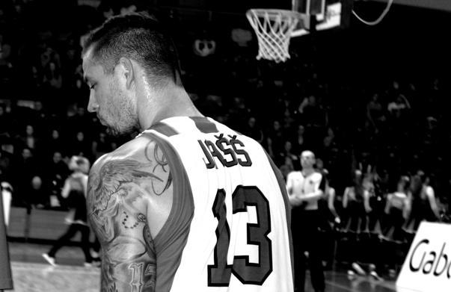

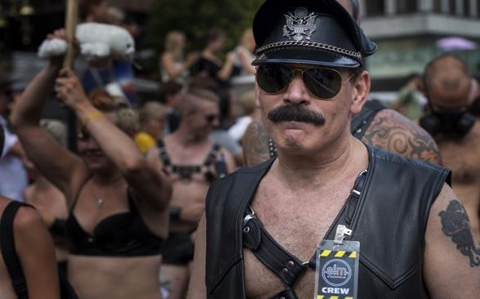
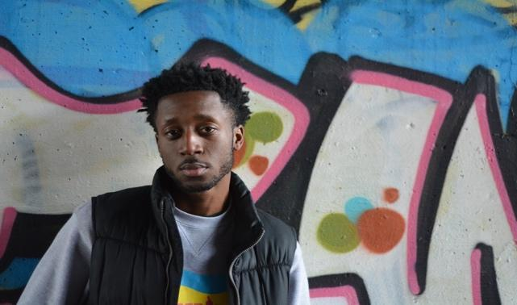

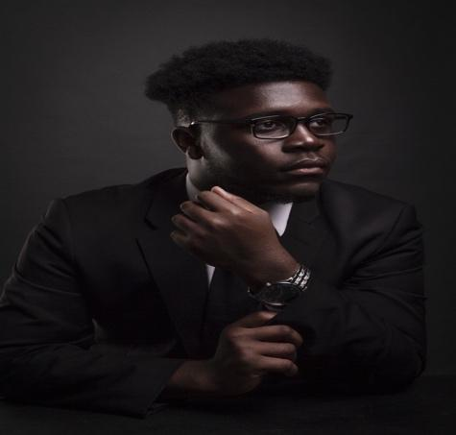
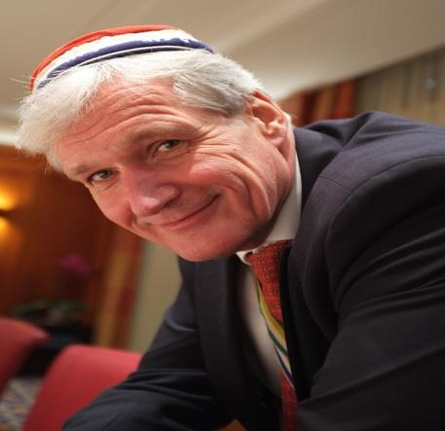

SET B

