Teachers’ notes Level B1.1

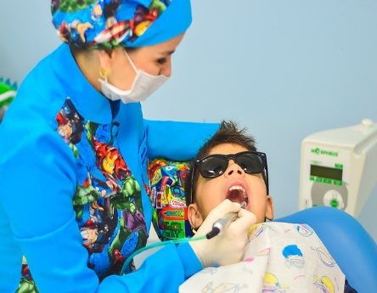
Lesson outcomes
By the end of the lesson students will have:
- created awareness of the importance of regular dental check-ups and dental hygiene.
- shared and clarified vocabulary needed at the dentist’s.
- practised making an appointment.
- practised explaining problems to the dentist.

Materials
Handout for students
Appendices
PPT
All images taken from Pixabay.com

Time | Procedure | Materials
10 minutes | Activity 1: Then and Now  - Display lesson objectives.  - Why are people often afraid of going to the dentist’s?  - Show the 2 photos of dentists: THEN and NOW (Appendix 1)  - Which of the 2 dentists would students prefer to work on their teeth? Why? Try to bring in vocabulary like: to hurt, pain and painful, to fill a tooth, to take out a tooth, hygienic and dirty. | PPT
15 minutes  15 minutes  15 minutes | Activity 2: Vocabulary  - Pre-teach some typical phraseology linked to the dentist’s: check-up, (to have) toothache, tooth decay, to have/give an anaesthetic (or anesthetic) to open (your mouth) wide, to fill a tooth, to take out a tooth, to clean your teeth, to floss your teeth. Tell students to check the glossary for these phrases.  - Ask students to listen to a short conversation between the dentist and the patient. What is the problem? She has tooth decay.What does the dentist decide to do? To fill the tooth. Can he do it immediately? No. she must make an appointment.  - Ask students to listen again. Tell them to complete the 5 sentences from the dialogue.  - Hi! It’s just for a check up, is it? 2. No not really. I’ve got toothache. 3.Oh dear, let me have a look! Put these goggles on please. Now, put your head back and open your mouth wide. 4.Yes, there is some decay. I’m afraid I’m going to have to drill and fill that tooth. 5.You’ll need to book an appointment at the reception.  - Let students check the sentences in pairs and then go through them together.  Activity 3: Dentist and Dental Hygienist  - Ask students if anyone knows the difference between the work of a dental hygienist and that of a dentist. Explain that they usually work in the same practice but the roles are different.  - Show the students a list of actions and invite them to divide them into the work of the dental hygienist and the work of the dentist. This activity is designed to recycle and add to the vocabulary.  - The students go through their lists with their partners and then all together in plenary.  Activity 4: Roleplay  - Put students into groups to prepare 2 dialogues: 1. Making an appointment 2. Explaining a problem to the dentist. Tell them to use the new vocabulary and phraseology from this lesson. Set a time limit of 10 minutes.  - Go through the dialogues together.
5 minutes | Reflection  - Remind students that if they are not registered with a dentist, it is important to do so.  - Ask them the advantages of going to the dentist’s regularly.  - Tell them to spend time looking for dentist’s surgeries or practices around the area where they live.  - Tell them to check on the local authority website. they may be eligible for free treatment.

Students’ handout
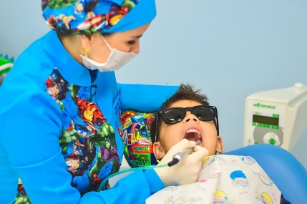
Lesson Outcomes
By the end of the lesson you will have:
- become aware of the importance of regular dental check-ups and dental hygiene.
- shared and clarified vocabulary needed at the dentist’s.
- practised making an appointment.
- practised explaining problems to the dentist.

Activity 1: Then and Now
- Why are people often afraid of going to the dentist’s?
- Look at the 2 photos of dentists: THEN and NOW (Appendix 1)
- Which of the 2 dentists would you prefer to work on your teeth? Why?
Activity 2: Vocabulary
- Look at the glossary for phrases about going to the dentists.
- Listen to a short conversation between the dentist and the patient. What is the problem? What does the dentist decide to do? Can he do it immediately?
- Listen again. Complete the 5 sentences from the dialogue.
- Hi! It’s just for a ……………………………… is it?
- No not really. I’ve got …………………………………
- Oh dear, let me have a look! Put these goggles on please. Now, put your head back and open your mouth ………………….
- Yes, there is some decay. I’m afraid I’m going to have to …………and ………….. that tooth.
- You’ll need to ………………………………. an appointment at the reception.
- Now check your answers in pairs and then go through them all together.

Activity 3: Dentist and Dental Hygienist
Does anyone know the difference between the work of a dental hygienist and that of a dentist? They usually work in the same practice but the roles are different.
- Look at the list of actions in appendix 2 and divide them into the work of the dental hygienist and the work of the dentist.
Go through your list with your partner and then all together in plenary.
Activity 4: Roleplay
- The teacher will put you into groups to prepare 2 short dialogues: a. Making an appointment b. Explaining a problem to the dentist. Use the new vocabulary and phrases from this lesson and look at the language box.
- Go through the dialogues all together.
Reflection
- Remember that if you are not registered with a dentist, it is important to do so.
- What are the advantages of going to the dentist’s regularly?
- Spend some time looking for dentist’s surgeries or practices around the area where you live.
- Check on the local authority website. You may be eligible for free treatment.

Glossary:

- To book/to have a check-up.
- (To have) toothache.
- To have tooth decay.
- To have/give an anaesthetic (or anesthetic).
- To open (your mouth) wide.
- To swallow.
- to fill a tooth.
- to take out a tooth.
- to clean your teeth.
- to floss your teeth.

Language Box:
Making an appointment.
- Good morning!/good afternoon!/good evening!
I’d like to make an appointment for a check-up please/ Can I make an appointment for a check-up please?
- Next Friday at 10am?
- I’m sorry, but I’m busy on Friday morning. Is Thursday possible?
- Thursday afternoon at half past three?
- Thursday afternoon at half past three? Yes that will be fine.
- Can I have your name please?
- Maria-Rosa Zille.
- And your mobile number?
- 349 872246
- Would you like us to send you a reminder the day before?
- Yes, thank you very much!

Appendix !: Then
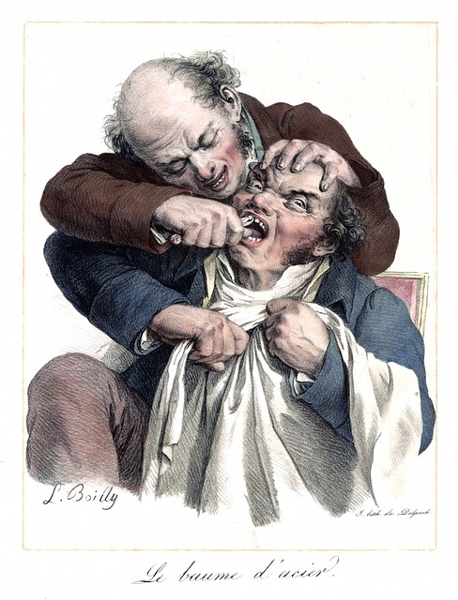

Appendix 1: Now

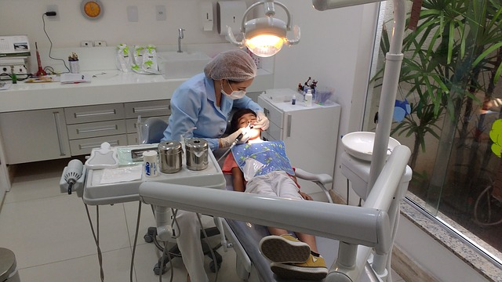

Appendix 2 : Dentist or Dental Hygienist?
Who:

- Cleans the teeth.

- Cleans dental decay and fills the tooth.

- Takes out diseased teeth.

- Polishes the teeth.

- Makes false teeth or sets of dentures.

- Deals with diseased gums.

- Drills out the decay from teeth.

- Deals with injuries to teeth.

- Suggests the best toothbrush to use.

- Prepares a paste to fill the holes left by drilling.

- Gives advice about how to clean teeth accurately.

- Keeps records of patients’ teeth.

- Suggests flossing, or cleaning between the teeth.

- Takes X-rays.

- Cleans plaque and tartar from teeth.

- Suggests the best toothpaste to use.

Answers: 1.Hygienist 2. Dentist 3. Dentist 4. Hygienist 5.Dentist 6. Dentist 7. Dentist 8.Dentist 9. Hygienist 10. Dentist 11. Hygienist 12. Dentist 13. Hygienist 14. Dentist 15. Hygienist 16. Hygienist.

Appendix 3
At the dentist’s
Transcription of the listening

Dentist: Hi! It’s just for a check-up, is it?

Patient: No, not really. I’ve got toothache.

Dentist: Oh dear! Let me have a look! Put these goggles on please. Now, put your head back and open your mouth wide …. Yes, there is some decay there. I’m afraid I’m going to have to drill and fill that tooth.

Patient: Can you do it now?

Dentist: No, I’m afraid you’ll need to book an appointment at the reception.

Patient: Okay, thank you.

