Teachers’ notes
Culture Greetings B1.2
Learning outcomes
By the end of the lesson students will have:
- looked at different types of greeting
- explored what factors might influence the way we greet people
- discussed how they greet and say bye to people in different contexts

Materials
Student’s handout / PPT
All images taken from Pixabay.com

Time | Procedure | Materials
5 minutes | - Display and clarify lesson objectives | PPT
10 – 15 minutes | - To engage students and generate interest, ask students to briefly count the number of people they have said hello to today. They do not need to say the exact number. Find out who has said hello to the most people so far today.  - Ask students to label the pictures in Activity 1 and to answer the questions at the bottom of the activity then conduct whole class feedback to go over the answers. You may need to teach words such as colleague and close friend.  [Suggested answers:  Relationships  a) probably people from two different companies - working relationship (colleagues)  b) probably two sisters but could also be two close friends  c) probably boyfriend and girlfriend or husband and wife  Types of Greeting  a) handshake  b) kiss  c) hug  d) high five  e) bow | PPT  Activity 1
15 minutes | - Ask students to complete the questionnaire in Activity 2 on their own. Put them into groups according to nationality so that, as far as possible, there is a mix of nationalities in each group. If some members of the group are from the same country, ask them to think about whether they all agree on the answers. If they are from different countries, get them to tell each other how they greet people in their countries. They could then each teach the other students one greeting in their first language. Conduct whole class feedback.  Possible ideas to focus on:  For Question 2 ask students if they know any languages which have the same word for both ‘hello’ and ‘goodbye’. There are quite a few (e.g. Italian, Czech, (Brazilian) Portuguese all use a variation of ‘ciao’ for hello and goodbye).  For Question 3 ask students if they kiss, and if so, how many times do they kiss (this can vary between 1-3). You could also ask them if they know of any other countries where people kiss and if they know of any countries where they have no physical contact at all (in Japan they do not usually make any contact; they bow to each other).  Answers for Question 4 may vary as it depends on the individual.  Some of these questions might be difficult for younger students who might not be used to speaking to people who they do not know personally. Also, they may not know if people say hello to cleaners and security staff if they have not had much exposure to working environments so this is a good opportunity to focus on this.  Don’t spend too long on question 5 as it is focussed on in Activity 3. | PPT  Activity 2
10 – 15 minutes | - Ask students to look through the answers people gave to Question 5 of the survey. Tell them to match the answers to the questions and let them know that although some answers could be used for more than one question, they should try to find the best answer for each question (Activity 3). Remind students these are not the complete answers but just extracts from them. There are clues in the extracts to help them identify which question they relate to. Before they start on the activity, check understanding of ‘show affection’ and ‘respect my elders.’ When they have finished, ask them to check their answers in pairs then conduct whole class feedback. Use this as an opportunity to discuss the norms in your country. You can discuss how people normally greet and in what way in your country; how public displays of affection are perceived in your country; terms young people may use to address each other and anything else that would help young people understand your country better.  [Suggested answers: a) 3 b) 4 c) 1 d) 6 e) 2 f) 5] | PPT  Activity 3
15 minutes | - Give students Activity 4 and ask them to complete the table thinking about how they would greet somebody and say goodbye to them according to who they are. They should also say if it would be accompanied by an action (e.g. a hug or a kiss). Put them into small groups to compare their answers. Conduct whole class feedback and comment on the suitability of these in their new country. | PPT  Activity 4

Culture Greetings
Learning Outcome
By the end of the lesson you will have:
- identified different ways people greet each other
- looked at some of the things that influence how we greet each other
- talked about the way you say hello and bye to different people

Activity 1: The way we greet
Look at the pictures below and answer the questions on the next page.

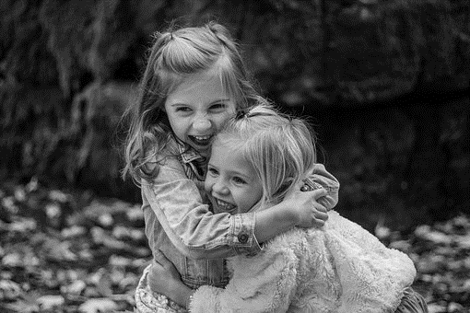
A B

C

D

E

Relationships
What do you think is the relationship between the people in Pictures A-C?

A………………………………………………………………………………………………………………………………………………

B………………………………………………………………………………………………………………………………………………

C………………………………………………………………………………………………………………………………………………

Type of Greeting
How are the people greeting each other in the pictures?
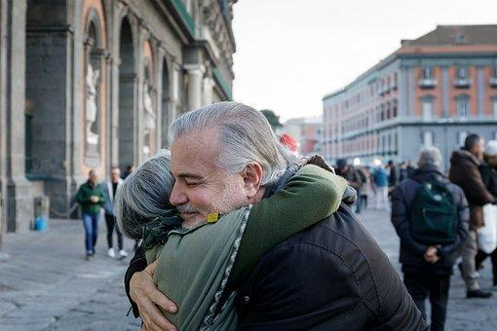
A………………………………………..

B………………………………………..

C………………………………………..

D………………………………………..

E………………………………………..

1) Do you associate any of the greetings with any particular countries? If so, which ones?

………………………………………………………………………………………………………………………………………………………………………………………………………………………………………………………………………………………………

2) Which of these ways of greeting are common in your country?

………………………………………………………………………………………………………………………………………………………………………………………………………………………………………………………………………………………………

Activity 2: The Greetings Questionnaire

Complete the questionnaire below.

This is a questionnaire to find out how people greet each other in different countries around the world.

- How many different words do you have in your first language to greet a person?
……………………………………………………………………………………………
- Is the word for ‘hello’ the same word used for ‘goodbye’ in your first language?
……………………………………………………………………………………………
- Do people in your country usually make physical contact when they greet someone? (for example, do they shake hands, kiss, hug, etc)
……………………………………………………………………………………………
- Which of the following people is it normal for you to greet in your country?

    - people who live near you but you do not know personally
    - bus drivers when you get on a bus
    - cleaners and security guards in your workplace

Some people greet and say goodbye to most people in the same way but others greet people and say goodbye to people differently depending on different things. The next question is specifically about you.

- Which of the following may influence the way you greet someone?

- Who they are

- Their age

- Where you are

- The time of the day

- When you last saw them

- When you will see them next

Activity 3: Same or different?

Look at some of the answers given by people to Question 5 of the survey. Match the answers to the questions. Some answers could be used for more than one question but try to find the best answer for each question.
- Who they are | - I used to feel a bit uncomfortable about showing affection – kissing and hugging – in public places but now I don’t mind so much. The only place I do feel uncomfortable is at school or when my school friends are around.
- Their age | - If it’s been a while since we met, I usually give good friends and family a big hug and kiss them on each cheek.
- Where you are | - Of course, this makes a big difference. For family and friends, I use more informal greetings. With my friends I usually say ‘Hiya’ but my brother and his friends are even more informal and say things like ‘What’s up?’ to each other.
- The time of the day | - When I was younger, my parents told me that I should show respect to my elders, so I usually use more polite forms with older people. There’s not a big difference but I might say ‘Hello’ and not ‘Hi’ and ‘Goodbye’ not ‘Bye’.
- When you last saw them | - If I go away or a friend goes away, I do the same as when I haven’t seen someone for a long time. I give them a hug, a kiss and tell them to keep in touch on WhatsApp.
- When you will see them next | - Most of the time I just say hello. It doesn’t matter what time of the day it is. I sometimes say ‘Good morning’ when I get up and see my parents and sometimes in some more formal situations but I don’t normally say it to friends.
a) ………. b) ………. c) ………. d) ………. e) ………. f) ……….

Compare your answers with your partner
Activity 4: Saying ‘hi’ and saying ‘bye’
Complete the table below. Write down what you would probably say and do (e.g. kiss, high five, wave) greeting and saying goodbye to the following people.

The first one has been done as an example. Do not worry if you would say and do the same thing for several people.

Saying Hello |  | Saying Goodbye
What you’d say  Hello Sir  Or  Good morning Sir | Teacher | What you’d say  Bye Sir
What you’d do  I don’t usually do anything |  | What you’d do  When I was younger, I would wave goodbye but now I don’t do anything.
What you’d say | Best friend | What you’d say
What you’d do |  | What you’d do
What you’d say | Boss at work | What you’d say
What you’d do |  | What you’d do
What you’d say | Colleague at work | What you’d say
What you’d do |  | What you’d do
What you’d say | Partner (boyfriend/girlfriend) | What you’d say
What you’d do |  | What you’d do
What you’d say | Sibling (brother/sister) | What you’d say
What you’d do |  | What you’d do
What you’d say | Parent | What you’d say
What you’d do |  | What you’d do
What you’d say | Someone interviewing you for a job | What you’d say
What you’d do |  | What you’d do
What you’d say | Doctor | What you’d say
What you’d do |  | What you’d do

