Teachers’ notes
Culture Appropriate Behaviour B1.2
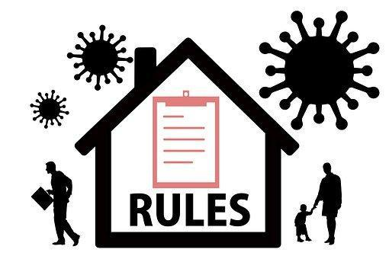
Learning outcomes
By the end of the lesson, the students will have:
- listened to somebody talking about what surprised her in a new place
- shared their views on what is normal / acceptable behaviour
- practised asking people not to do certain things

Materials
Student’s handout / PPT
All images taken from Pixabay.com
Tapescript
Appendix 1: behaviour cards (cut up if the lesson is to be delivered face to face). One set per 3 or 4 students

Time | Procedure | Materials
5 mins | - Display and clarify learning outcomes. | PPT
10-15 minutes | - Ask students how many of them have been on public transport in different countries. What did they notice that was different or even strange from their own country/countries (for anyone who has lived in more than one country).  - Tell students they are going to listen to someone talking about her first experience of going on a bus in London. Ask them to predict anything she might talk about. Tell them to listen and list the three things she particularly found strange. Read the text in the teachers’ notes.  Answers:  1. people stood in a queue to wait for the bus and then queued to get on the bus  2. a woman put makeup on whilst she was on the bus  3. a couple were hugging and kissing on the bus  - Ask students whether any of these things seems strange or surprising to them.  - Tell students they are now going to think about other things they have noticed that have been strange or different or even rude in different places they have been. If anyone has lived in different places, ask them to think about things that were strange to them in a new place but that they have since gotten used to. You could teach them ‘I used to think XXX was strange but now I am used to it.’ Put them into small groups/create breakout rooms to discuss. Conduct whole class feedback | PPT  Activity 1  a & b
20 minutes | - Tell students they are going to talk about other examples of behaviour that they might find strange, different or even rude. Focus on the fact that certain types of behaviour are rude in some cultures but not others and in some families and not others. Also highlight the fact that it can depend on how well you know somebody, i.e. things might be acceptable from a family member or close friend but not someone you don’t know very well. You could possibly give your own examples of things you find strange or different when you visit other people (not necessarily cross-cultural differences; it could be your grandma’s habits) or countries (also nice differences!).  - If you are teaching in a classroom, put students in small groups sitting around a table and give each group a set of cards. These should be placed face down on the table. In an online classroom, you will need to give them the whole set together on the handout depending on the online platform you are using. Before the students do the activity, check their understanding of ‘to spit’, ‘to burp.’ Conduct whole class feedback. | PPT  Activity 2
15 minutes | - Tell students they are going to look at some potentially tricky situations and consider how they might react to them. Give them time to read each scenario individually and think about what they would do. Check they understand the term ‘about to...’  - Focus their attention on the language box, drill each of the exponents and explore in what situations they would use them i.e., that you are likely to use ‘please don’t’ with people you know well and ‘I’d appreciate it if…’ with people you know less well. Do the example with two students then tell students to work in pairs to create their own mini dialogues.  Conduct whole class feedback. | PPT  Activity 3
5 mins | - Conduct a plenary and ask students to reflect on the questions. Discuss why it is important to be aware of different attitudes to behaviour focusing on the need to try to fit in and not offend people from different backgrounds. Also ask them whether they think it is important to change their own habits to fit in. | Activity 4

Script for Activity 1
Leena: “I remember the first time I went on a bus very clearly because there were certain things about it that really shocked me. First of all, I noticed that people were queuing at the bus stop waiting for the bus to arrive. When it did, they waited in turn to get onto the bus. That would never happen in my country; when the bus arrives there, everyone just pushes to get on. Then I noticed, one woman sitting on the bus putting her makeup on. I couldn’t understand why she did it on the bus rather than at home before she came out. I looked around the bus at the other passengers and saw a couple kissing and cuddling on the bus! I couldn’t believe it, in my country, all physical contact is private. You would never kiss someone in public or even hold hands. I’ve been here a few years now so I am used to these things but they seemed very strange to me when I first arrived!”

Culture Appropriate Behaviour
Learning outcomes
By the end of the lesson, you will have:
- listened to somebody talking about what surprised her in a new place
- shared your views on what is normal / acceptable behaviour
- practised asking people not to do certain things

Activity 1: Strange behaviour
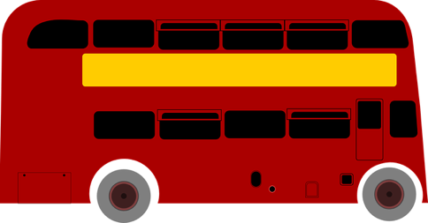
a 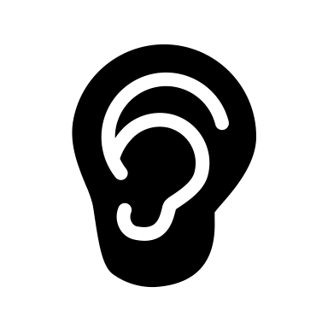Listen to Leena’s story. What three things surprised her about her first bus journey in London.

Are the things she mentions strange, surprising or normal to you?

b Think about different places you have been in different countries. Did you notice anything different about the way people behaved in their homes, at school, in the workplace, on public transport? Tell your classmates what you observed.

Activity 2: What’s normal behaviour?
Your teacher will give you a set of cards. Turn each one over and discuss it with the people in your group. In your opinion is the action described:
- strange
- rude
- totally acceptable
- acceptable in some situations but not others
- dependent on how well you know somebody

Activity 3: Dealing with tricky situations
a Look at the situations on the next page. What would you do if they happened you? Would you ignore the situation, or would you speak up?

2 Someone you don’t know very well is visiting you at home. They take a cigarette out and are about to light it. You don’t like people smoking in your home.

1 You invited a work colleague to dinner at your house. After the meal, you are all sitting in the living room and your colleague puts their feet on the sofa.

4 You are in the cinema and the people next to you are eating popcorn noisily and chatting throughout the film so you are finding it difficult to concentrate on the film.

5 You are in a restaurant with a friend and they keep looking at their mobile phone.

3 Your friend keeps ringing you late at night. You are often about to go to bed or in bed so don’t to be disturbed.

b When someone does something you are unhappy about, you might want to tell them you are unhappy. How you do this can depend on how well you know them. Often when you do this, you give them a reason. Work with a partner. Choose some of the situations above and create short dialogues using the language from the language box.

For example
A friend arrives at your house and is about to walk into the house without taking their shoes off. Your family likes everyone to take their shoes off when they come into the house as a sign of respect and to keep the house clean.

A: Would you mind taking your shoes off before we go into the sitting room? Where my family originally comes from it’s a sign of respect and also it keeps the house clean.

B: Sure, no problem. I didn’t realise you did that. Where shall I put them?

Language Box: Making negative requests
Asking people not to do things  Please don’t / could you + bare infinitive  Do you think you could + bare infinitive  Would you mind not + -ing  Sorry to ask but please stop + -ing  I’d appreciate it if you could + bare infinitive | Responding to requests not to do things  Of course, sorry about that.  I’m sorry, I won’t do it again.  Sure / no problem. I didn’t realise it was a problem.

Activity 4: Reflection
How important is it to be aware of what is acceptable behaviour in someone’s house / different country?
How can you find out what is acceptable or not acceptable in different situations?
Have you or anyone you know changed their behaviour as a result of living in a different place?

Appendix 1

feeding a dog at the dinner table |  | answering your mobile phone in the middle of a meal
lighting up a cigarette in someone’s home without asking |  | eating as you are walking along the street
putting your feet on the furniture |  | chewing gum whilst talking to somebody
taking your shoes off when you go into somebody’s home |  | going round to visit someone without arranging it beforehand

asking someone how much they earn |  | spitting on the street
burping in public |  | borrowing something that belongs to someone else without asking

talking and eating through a film in the cinema |  | paying for everyone’s meal in a restaurant

arriving late without letting anyone know that you are going to be late |  | phoning someone very early in the morning or late at night

