Teachers’ notes Level B1.2

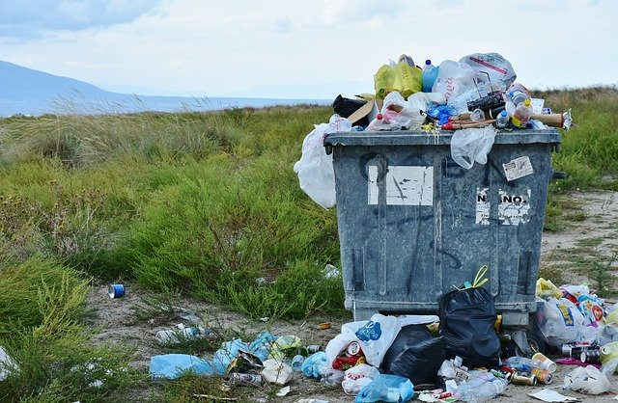
Lesson outcomes
By the end of the lesson students will have:
- discussed the importance of reducing waste.
- watched a video about reducing, reusing and recycling.
- presented an idea about reducing, reusing or recycling.
- used the language of persuasion.

Materials
https://youtu.be/hX8XTOR-WV8 British Council video “Cutting down on waste”.
Handout for students
PPT
All images taken from Pixabay.com

Time | Procedure | Materials
5 minutes | Activity 1: How can we cut down on waste? Brainstorm.  - Display lesson objectives  - How many ways can students think of to cut down on the amount of waste they produce every day?  eg. not using plastic, not buying food in packaging …..  - Why is it important? | PPT
5 minutes  10 minutes  15 minutes  20 minutes | Activity 2: The video:  https://youtu.be/hX8XTOR-WV8 “Cutting down on waste”.  - Before students watch the video, ask them to listen for the 3 r’s”. What are they?  Answer: Reduce, reuse, recycle  Activity 3: Discussion  - How can we reduce waste?  - What can we reuse ?  - What can we recycle?  Let students work in pairs to discuss what they understood about these topics from the video.  Now write all their ideas on the board.  Activity 4: Watch and listen  - Tell the students to watch the video again, listen to what Sofia suggests about reducing, reusing and recycling and make notes.  - What are Sofia’s ideas?  - Do the students agree that they are useful ideas? Why?  Why not?  - What additional ways can students suggest to reduce, reuse and recycle?  - The students can read the transcript or watch the video with subtitles if they want to.  Activity 5: Creating your pitch.  - Ask each pair to choose a way of reducing, reusing or recycling.  - Ask them to prepare to “sell” their idea to a group of people listening to them.  - Ask them to check the language of persuading someone to do things in the language box.  - Make notes and a list of keywords.  - Each pair presents their idea.
5 minutes | Reflection  - Which was the most convincing idea?  - How careful are the students already about reducing, recycling and reusing?  - How will they try to reduce, reuse and recycle more in the future?

Students’ handout

Lesson Outcomes
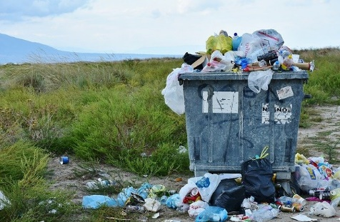
By the end of the lesson you will have:
- discussed the importance of reducing waste.
- watched a video about reducing, reusing and recycling.
- presented an idea about reducing, reusing or recycling.
- used the language of persuasion.

Activity 1: How can we cut down on waste? Brainstorm.
- How many ways can you think of to cut down on the amount of waste we produce every day? eg. refusing plastic bags, not buying plastic packaging
- Why is it important?

Activity 2: Watch the video, https://youtu.be/hX8XTOR-WV8 “Cutting down on waste”.
- While you watch the video, listen for the 3 r’s”. What are they?

Activity 3: Discussion
- How can we reduce waste?
- What can we reuse ?
- What can we recycle?
Work in pairs to discuss what you have understood about these topics from the video.

Activity 4: Watch and listen
- Watch the video again, listen to what Sofia suggests about reducing, reusing and recycling and make notes.
- What are Sofia’s ideas?
- Do you agree that they are useful ideas? Why? Why not?
- Read the transcript or watch the video with the subtitles if you want to.
- What additional ways can you suggest to reduce, reuse and recycle?
Activity 5: Creating your pitch.
- In pairs, choose a way of reducing, reusing or recycling.
- Prepare to “sell” the idea to a group of people listening to you speaking.
- Check the language of persuading someone to do something in the language box.
- Make notes and a list of keywords.
- Each pair presents their idea.

Reflection

- Which was the most convincing idea?
- How careful are you already about reducing, recycling and reusing?
- How will you try to reduce, reuse and recycle more in the future?

Language Box

Persuading someone to do something:
- We/you really should try …. eg. …. to cut down on using plastic …..
- If we/you just think beforehand, we can eg. …. save a lot of electricity.
- Try to eg. …. reuse plastic containers to keep things in.
- Try not to eg. …… eat so much meat.
- You’d really be helping out eg ……. if you bought fruit loose from the market stalls and take a bag with you.
- We don’t need to eg. …… always buy new clothes. Try looking in charity shops.
We needn’t eg. …… throw away new clothes. Take them to a charity shop.
It isn’t necessary to ….. eg. …… wash clothes at really high temperatures.

Glossary
To reduce waste = to cut down on waste by eliminating it eg. plastic packaging.
To reuse = to use again eg. gift wrapping paper.
To recycle = turn waste into something “new” eg. clothes, furniture (also known as “upcycling”).

