Teachers’ notes
Culture At What Age? B1.2
Learning outcomes
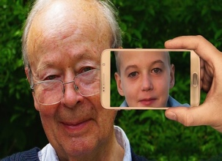
By the end of the lesson students will have:
- found out about the school starting and leaving ages in a few countries
around the world
- compared when you can do different things in different countries
- discussed looking after children in different countries

Materials
Student’s handout / PPT
All images taken from Pixabay.com

Time | Procedure | Materials
5 minutes | - Display and clarify lesson objectives | PPT
10 minutes | - Ask students to think back to their first day of school using the prompts then share their experiences with their partner. Ask them what age they start and finish school in the country they come from / live in now. Ask them if they feel the age that they were was the right age to start and finish school. | PPT
15 minutes | - Tell students to work on their own to try to complete Activity 1b. Tell them to check their answers in pairs. Conduct whole class feedback. Ask them why they think different countries have different school starting and finishing ages.  Answers  Australia 5 /17  Canada 6 / 16  Hungary 3 / 16  Luxembourg 4 / 16  South Africa 7 /15 | PPT  Activity 1
15 minutes | - Ask students to complete Activity 2. They may need to do some research to complete it. Encourage students from different countries, to find out about the countries they have come from. Explain that in some cases there may not be a legal age at which something can be done e.g. in Austria, Croatia, Germany, Italy, Lithuania, Romania and Spain you can get a tattoo at 16 but you must have parental consent. Other places in Europe such as Belgium, Czech Republic, Estonia, Hungary, Luxembourg, Poland, Slovakia, Slovenia and Sweden have no legislative age restrictions on tattooing.  - When students have finished, put them into small groups to compare the information they have and their answers the questions in b and c. Conduct whole class feedback. Also ask them what age they think people should be able to do certain things – ask them to justify their reasoning. | PPT  Activity 2 a, b and c
10 minutes | - Ask students what experience they have of looking after children and introduce the word ‘babysit.’ Focus on what happens in the UK and then ask them to discuss the questions in small groups to discuss what happens in other countries. Before they start the activity, ask them to look at the language box and encourage them to use the language to give opinions and agree and disagree.  - If learners have mobile phones on them and there is an interactive white board/screen the session could be made interactive by inviting students to share their ideas via https://www.mentimeter.com/  - Conduct whole class feedback. You could also ask them the following questions:  If babysitters were required to be at least 16, then would a 15-year-old mother be allowed to look after her own child?  In the UK if the babysitter is under 16, then the parent remains legally responsible for the child's safety. They could be cautioned if something was to happen to the child. Is this fair?  How long is it OK for parents to leave a child with a babysitter? | Activity 3
5 minutes | Reflection  - Ask students what they have learnt about their new country today. Was there anything that surprised them?

Culture At What Age?
Learning Outcome
By the end of the lesson you will have:
- found out about the school starting and leaving ages in a few countries
around the world
- compared when you can do different things in different countries
- discussed looking after children in different countries
Activity 1: School Age

a Think back to your first day at school. How old were you? What can you remember? Think about the classroom, the teacher, the other children and what you did.
At what age do children start and finish school in any countries that you have lived in?

b The age children start and leave school is different around the world. Complete the table below. Use the numbers in the box. The school starting age is different for each of the countries, but some countries have the same leaving age.

5 16 7 15 6 3 17 4

School starting age |  |  | School leaving age
Australia | ___ |  | ___
Canada | ___ |  | ___
Hungary | ___ |  | ___
Luxembourg | ___ |  | ___
South Africa | ___ |  | ___
Compare your answers in pairs. Discuss with your partner anything that surprises you.
Why do you think there are different school starting ages?
Activity 2: When can you do it?
a Complete the questionnaire below. If you don’t know any of the answers, do
some research.
At what age can you … | Where you  live now | Another country you know about
- look after children / babysit?

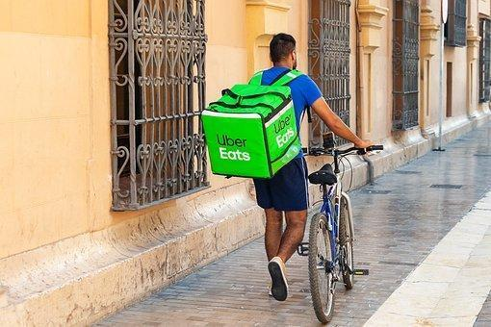
- get a job?

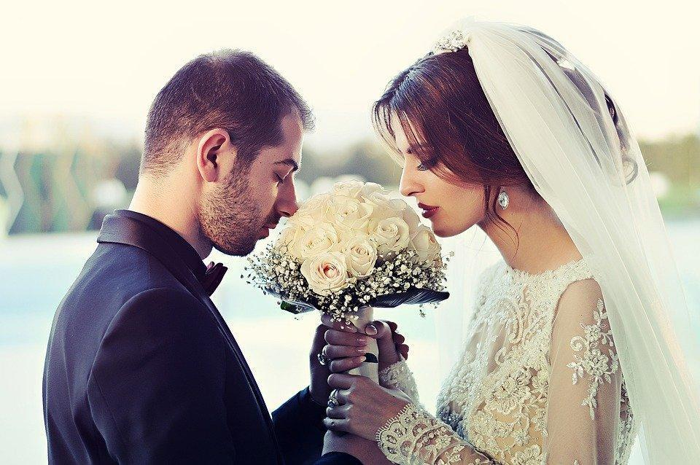
- get married?

- drive a car?
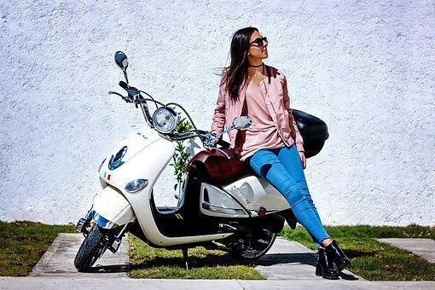
- ride a motorbike?

- vote?
- vape or smoke?
- buy a lottery ticket?

- get a tattoo?
- get a Facebook or Instagram account?

b Work in groups to find out what happens in different countries.

c Discuss these questions:
Why do you think the rules are different in different countries?
When do you think people should be able to do these things?

Activity 3: Looking after children
In the UK parents sometimes leave their children with grandparents, brothers/sisters, neighbours, family friends or babysitters. There is no minimum age for when someone can babysit. Discuss the questions below.

- Who looks after children when the parents go out in your country? Is it the grandparents, brothers/sisters, neighbours, family friends or babysitters?

- If it is a family member, should they be paid?

- Should there be a minimum age for babysitters? If so, what should that age be?

- Who should be responsible if something happens to child while they are looked after by a babysitter who is under 16?

- Do you think it’s acceptable for parents to leave younger children with their older brothers or sisters when they go out?

Language Box:  Expressing views and feelings  I think … / I don’t think …  For example: I think people should be paid to babysit  In my opinion …  For example: In my opinion, it’s ok for parents to leave younger children with their brother or sister if they are older than 14 | Agreeing and disagreeing  I agree …  For example: I agree, it’s fine for an older sibling to babysit their brother or sister  I don’t agree / disagree. I think / don’t think …  For example: I don’t agree / disagree. I don’t think you should pay people to look after their brothers and sisters

