Teachers’ notes Level B1.2

Lesson outcomes
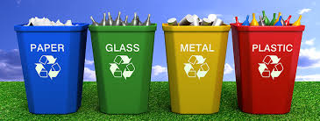
By the end of the lesson students will have:
- found out about recycling and reusing waste.
- worked in groups to prepare a presentation.
- prepared notes with keywords to present.
- practised speaking in public.

Materials
PPT
Cards to write notes and keywords on.
Some examples of recyclable waste to add interest (optional).
A laptop, smart phone or camera to film the presentation (optional).
Handout for students.
Appendices.
All images taken from Pixabay.com

Time | Procedure | Materials
10 minutes | Activity 1: Introduction  - Display lesson objectives.  - Tell students to find out about local recycling facilities.  - Students will prepare a short presentation – about 2-3 minutes - for a young teenage audience, about the advantages of recycling and reusing.  - Divide students into groups.  - Distribute copies of the “What’s recyclable and what’s not” leaflet to each group.  - Show them the visual of recyclables.  - Tell them to look at the vocabulary box and ask about new words. | PPT
20 minutes  15 minutes  10 minutes | Activity 2: Preparation  - In their groups, students decide whether to speak generally, or about a specific type of recycling or reusing.  - Give students 20 minutes to prepare their presentation.  - Monitor, encourage, suggest and help the groups.  - Tell them to write notes.  Activity 3: Practise  - Practise the presentations. Each member of the group must participate.  - Tell them to write keywords on postcards to remind them of what they want to say.  - Refer to the language box for phrases which they will need to use.  Activity 4: Present  - Bring the groups together.  - Each of the groups makes their presentation to the others.  - Film the presentations if you have the facilities (you only need a smart phone). | Flip charts or paper  Coloured board pens  Small cards or postcards  Access to a smart phone or laptop
5 minutes | Activity 5: Feedback and reflection  - How have students’ attitudes to recycling changed since they started living here.  - Compare the opportunities to recycle and reuse here and in another country.  - After the lesson, students listen to the recording of their work and think about the way they speak. Are their voices enthusiastic? Encouraging? Boring? Easy or difficult to understand? How will they try to communicate more effectively in the future?
Students’ handout

Lesson Outcomes
By the end of the lesson you will have:
- found out about recycling and reusing waste.
- worked in groups to prepare their presentation.
- prepared notes using keywords.
- practised speaking in public.

Activity 1: Introduction
- You are going to prepare a short presentation – about 2-3 minutes - for a young teenage audience, about the advantages of recycling and reusing.
- Your teacher will divide you into groups.
- Look at the “What’s recyclable and what’s not” leaflet and the visual of recyclable materials.
- Look at the vocabulary box and ask about any new words.
- Check the language box.
Activity 2: Preparation
- You have 20 minutes to prepare your presentation.
- Decide if you want to speak generally, or about a specific type of recycling or reusing.
- Write notes together about what you are going to say.
- Share the speaking, something for each of you.
- Look at the language box for useful phrases.
- Make notes.

Activity 3: Practise
- Practise your presentation.
- Check the timing 2-3 minutes speaking in total is sufficient.
Activity 4: Presentation
- Each of the groups makes their presentation to the others.
- Film the presentations if you can. (you only need a smart phone).
Activity 5: Reflection

- How have your attitudes to recycling changed since you started living here?
- Compare the opportunities to recycle and reuse here and in another country.
- Listen to the recording of your work after the lesson and think about the way you speak. Are your voices enthusiastic? Encouraging? Boring? Easy or difficult to understand?
- How will you try to communicate more effectively in the future?

Language Box:
Suggesting, encouraging and advising
Advising
We really should/ought to… (separate paper from plastic) ….
We should reduce packaging (as soon as possible).
Suggesting and encouraging
We could… (reuse ….)
It’s worth (it/verb + ing)… separating ……
Let’s try …… (separating and collecting) …….
It’s a great idea to …(take clothes to a charity shop…)
It’s really important to…( think about …)
Eg. We could (collect bottle tops and crisp packets for local recycling centres).
It’s worth washing (plastic food containers before they are collected).
Let’s try (separating clear glass from brown glass).
It’s really important to (reduce our use of plastic).
It’s a great idea to (set up shops selling good second-hand clothes, furniture and things for the house).
Glossary
Recycling vocabulary

Nouns
Different types of paper and paper goods – stationery, cardboard, catalogue, leaflet, flyer, tissue paper
Glass - jar, bottle, vase, glass and drinking glass
Metal and other - wax
(drink can) tin (paint tin), Lid/top/cover/cap
Foil/tin foil/aluminium foil
Adjectives
sharp
chargeable/non-chargeable
laminated
contaminated
disposable

Verbs
To rinse (wash again in clean water)
To squash (crush/squeeze/press together)
To sort (to put into groups)
To throw (out) (to dispose of)
To be left on (to not take off)
To contaminate (to pollute)
To laminate (to cover with plastic)

Appendix 1: Recycling leaflet
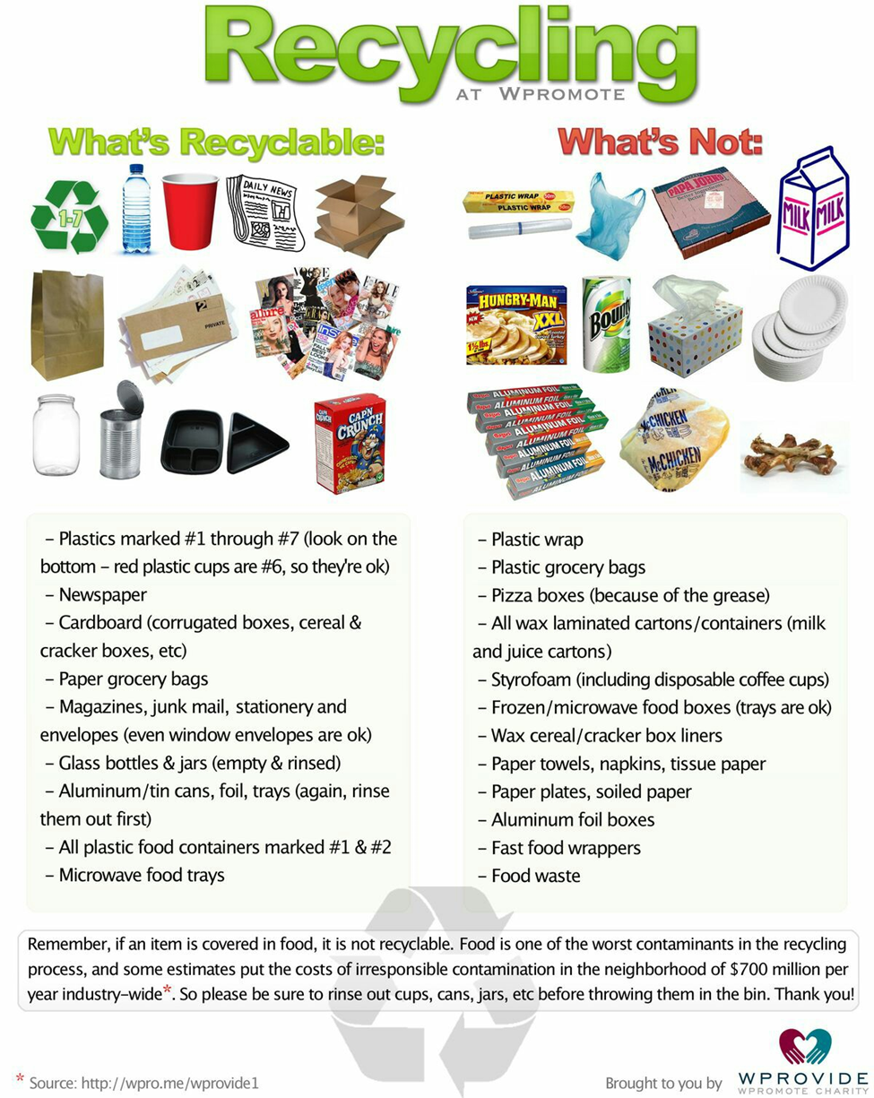
Appendix 2
What can we recycle and reuse?

