Teachers’ notes
Keeping Safe Online Safety B1.3
Learning outcomes
By the end of the lesson students will have:
- discussed common online risks and problems, and ways to protect themselves
- thought about what advice they would give to friends experiencing different problems online
- reflected on how safe they feel online, and who they can report worrying issues to

Materials
Student’s handout / PPT
All images taken from Pixabay.com

Time | Procedure | Materials
5 minutes | - Display and clarify lesson objectives. | PPT
15  minutes | - Introduce the activity by telling a short story about how your accounts were hacked. Don’t use the word; instead try to elicit it. Then ask them to think about other problems associated with online security. Note their ideas on the board then show them the table in Activity 1.  - Tell them that they are going to discuss whether they or anyone they know has experienced any of the things listed in Activity 1, including hacking. Put them into small groups and tell them to discuss what they know, have read or heard about these things. Explain that if they are unsure of any of the vocabulary, they can check the glossary on the next page. Monitor briefly.  - Afterwards, follow up with a whole class discussion – maybe students will have things they want to say, or you could ask questions – for example, ‘what can you do if you are contacted by someone you don’t know?’ (you can block them to prevent them from being able to contact you again). You can also explain that the word ‘phishing’ does come from ‘fishing’ – there is often a ‘bait’ used to trick people, for example they are offered something if they provide their details in return. | PPT  Activity 1
10 minutes | - Before the next activity, point out the language box, and ask some introductory questions to model the use of this language, for example: ‘Sara, how likely are you to go on Facebook this evening after the lesson?’ to which the student can look at the box and say ‘I am definitely going to go on Facebook this evening’ or ‘I’m quite unlikely to go on Facebook this evening.’ You can prompt and edit/correct as need be, and then ask another student and compare their answers: ‘so Andrea is much more likely than Sara to go on Facebook tonight.’  - Put students into small groups to compare their responses to the statements in Activity 2. Monitor and join in conversations; encourage students to discuss potential consequences of doing/not doing these actions.  - Once the groups have finished discussing, you could conduct a brief whole class discussion – maybe by asking the groups ‘Do you think you are good at staying safe online? Why? / Why not?’ so that students use the probability vocabulary in the language box. Or you could comment on some of the themes, for example the last statement about information sent through social media: ask students if they have heard of the term ‘fake news,’ and ask where they get their information/news from and how they can be sure that it is genuine. | PPT  Activity 2
15-20 minutes | - Tell students that they are going to read three texts from their friends who are all worried about online situations they are experiencing. In their group, they need to fill out the table – identifying if there are red flags in what the texts describe, if there is a term for what is happening, and what they would advise these individuals to do in their situations.  - You may want to elicit the concept of a ‘scam’ and of a ‘red flag,’ e.g. by asking a student something like ‘Hana, I have an offer for you. If you give me your bank details for me to store some money, I will let you keep half of that money. Do you want to do that?’ No? But it’s a great offer, why not?!’ Get the students to say that it sounds like a scam, and that being asked to give bank details is a red flag.  - Put students in groups to do the activity (change them around so they are not in the same groups as before). Monitor, check understanding of vocabulary and see what the students’ advice would be. Make notes – of there is some very good advice, ask students to share this when you come back together as a class.  - Once students have finished the activity, conduct a plenary. You may want to talk about solutions, and talk about the fact that you should tell different people depending on what the problem is:  - the police, if you feel threatened or are being harassed, or if worrying messages or photos are being sent to you  - your boss or HR in the workplace in the case of online harassment/bullying from colleagues  - your bank, if money is disappearing from your account – either by going into the bank or calling the real bank number (do not believe someone who calls you pretending to be the bank)  - a friend, for advice  - Facebook or another social media operator if you need to investigate something or block someone  - Let this plenary move into the final activity. | PPT  Activity 3
5-10 minutes | - To reflect on online safety, ask students to place themselves on a scale of how safe they feel online compared to in ‘real life’/the outside world. If teaching in person, you could have this line from one wall to another, and students line up. If online, you could use a virtual tool (like a collaborative whiteboard) where students can move or mark themselves. Or they can decide alone and then you can ask some students to share. You may discuss some of the topics in previous lessons on Staying Safe. You should point out that the ‘real’ and online worlds are of course the same one. | PPT  Activity 4
Keeping Safe Online Safety
Learning outcomes
By the end of the lesson, you will have:
- discussed common online risks and problems, and ways to protect yourself
- thought about what advice you would give to friends experiencing different problems online
- reflected on how safe you feel online, and who you can report worrying issues to

Activity 1: Online problems
Complete the table for you. √ = yes X = no. If you are still not sure of the vocabulary, check the glossary on the next page.

 | I have experience of it | I know someone who has experience of it
Hacking of email or social media account
Fake profile on social media

The dark web

Online identify theft

Malware

Catfishing/phishing

Targeted advertising

In small groups, compare what you know and your own and other people’s experiences.

Activity 2: How likely are you to …?

Language box: talking about the possibility of doing something
I would definitely …  There’s a good/no chance that …  It’s highly unlikely that …  I’m pretty sure that… | I’m not sure I’d bother to …  You could end up with …  I’d be worried that …

Use the language in the language box to talk about how likely you are to do the different things on the next page e.g.

There’s no chance that I’d have different passwords for different accounts. it’s too difficult to remember them all! I’d be worried that I wouldn’t be able to get into any of my accounts.

- Have the same password for different accounts
- Change your passwords regularly
- Log out from every account on shared computers and clear cookies
- Change the settings on your social media accounts to private so that only the people you choose can see your posts
- Identify/notice a fake online profile or post
- Be notified about pictures of yourself online that you didn’t post
- Accept friend requests from people you don’t know
- Google more details about information you are sent through social media

Activity 3: Unusual online activity
Three of your friends have experienced some unusual and upsetting activity online. In groups, read the messages from your friends and write down…
 | Eli | Dmitri | Saba
Which details tell you something seems wrong? (These details are red flags).

What are your friends experiencing — phishing? catfishing? A fake profile?

What would you say to your friend to help them; what is your advice? What should each person do in their situation?

Glossary
Hacking – getting access (without permission) to someone’s account or data in a computer/system.
Fake profile – a social media account which is used to pretend to be someone else, or which hides the identity of someone.
Catfishing – when someone makes a fake profile, usually to trick someone into giving them money.
Phishing – stealing data (e.g. login or banking details) by pretending to be a trusted sender.
Identity theft – to use another person’s name and personal information to get money or goods
The dark web – parts of the internet that can’t be found using normal search engines and often used for criminal activities
Malware – computer software designed damage how the computer works – similar to a virus
Targeted advertising – adverts that appear in your social media feed or internet searches based on your buying history or interests
Screenshot/screengrab – taking an image of the screen, to capture and keep a message/story/photo.
‘Doesn’t feel right’ / ‘feels off’ – when you have a feeling that something is wrong.
To wire money – to transfer money electronically. Wire transfers cannot be cancelled.
Legit – short for ‘legitimate,’ this is slang/colloquial English
Paranoid – feeling scared or worried, as if someone is targeting you or acting against you.
Red flag – a warning of danger (if something ‘feels off’ this might tell you that there’s a red flag).
Scam – a fake scheme with the goal of stealing money. Synonym = fraud.
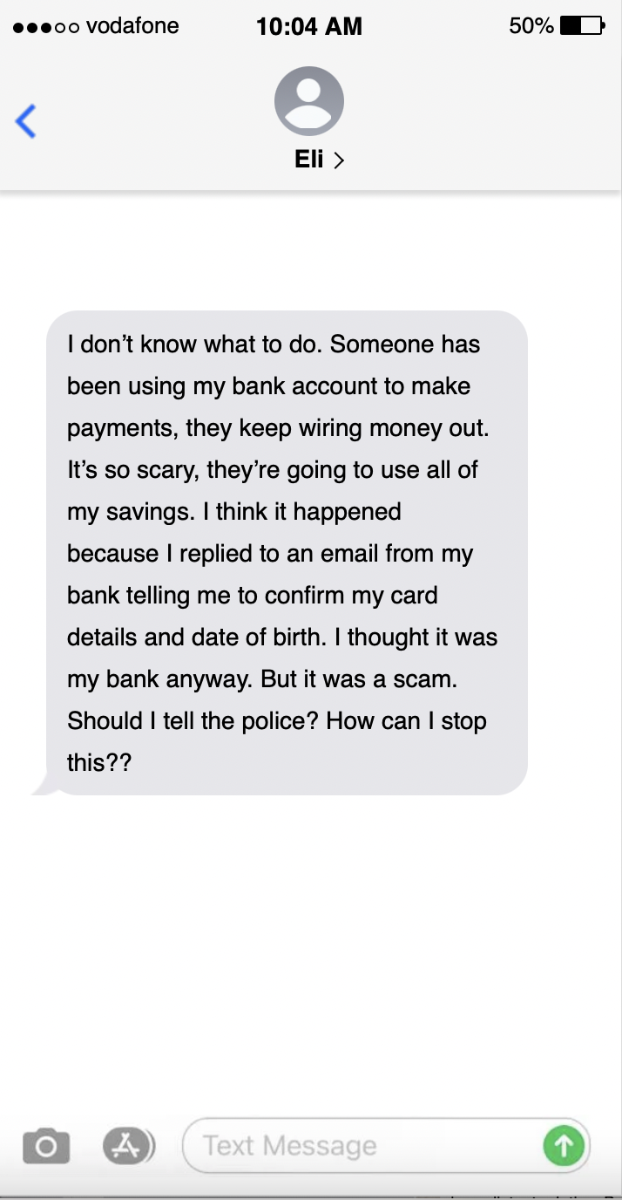
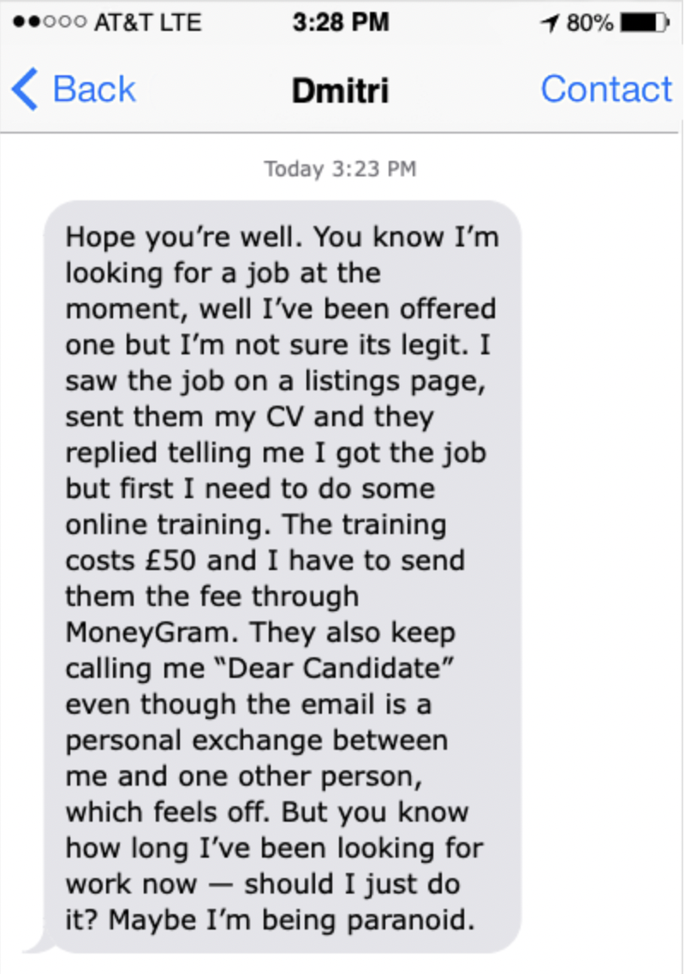
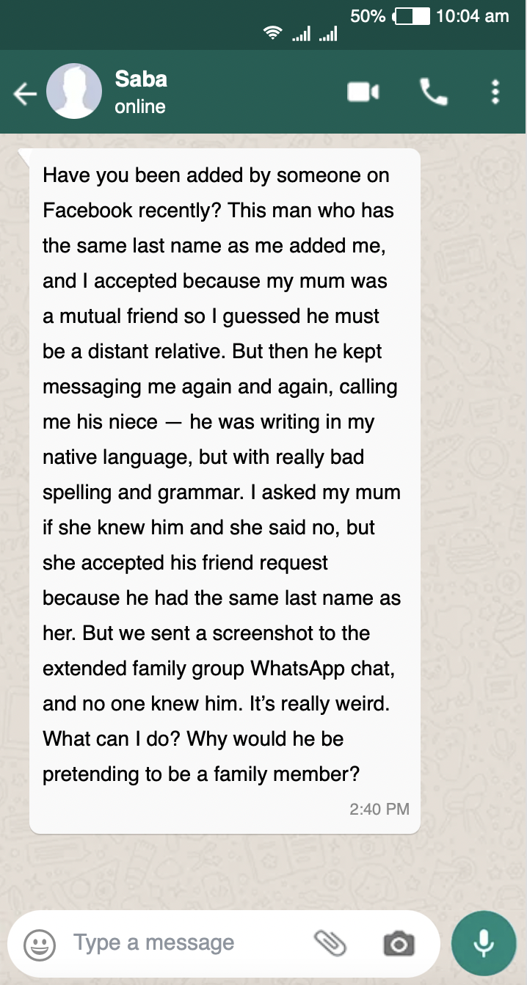

Activity 4: Reflection
Where would you place yourself on this scale? Why?
I feel safer in ‘real life’ than I do online
I feel safer online than I do in ‘real life’

