Teachers’ notes
Keeping Safe Keeping Safe At Work B1.1
Learning outcomes
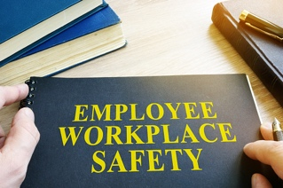
By the end of the lesson students will have:
- shared views on what keeping safe at work means
- looked at words connected to safety at work and discussed hazards in different jobs
- reviewed ways of asking for and giving opinions

Materials
Student’s handout
PPT
All images taken from Pixabay.com

Time | Procedure | Materials
5 mins | - Display and clarify learning outcomes. | PPT
15+ minutes | - Tell students that they will be discussing what keeping safe means in groups but first of all they have to put the words in the correct order to form questions. Depending on the group you may want to do the first one together as an example.  - Ask students to do 1.1 individually. Monitor and offer support as necessary.  - Display slide 2 with the questions unscrambled so they can check their answers. Focus on pronunciation as necessary.  - Place students in small groups/ create breakout rooms for groups of 4-5 students and ask them to discuss the questions. Explain that you are not expecting them to know the answers to all the questions but to exchange ideas. Monitor and offer support as necessary. Early finishers could complete the sentence stem. Alternatively, this can be done as a class.  - Conduct whole class feedback. Establish what the differences are between feeling physically safe and emotionally safe at work. Explain they are both important and workers have the right to both. | PPT  Activity 1
15  minutes | - Tell students they are going to work with a partner and look at some words connected to safety in the workplace. They need to decide whether they are connected to being physically safe (P), feeling emotionally safe (E) or both (B). Encourage them to look up words they are not familiar with.  - Before placing students in small groups elicit different ways of asking for someone's opinion and giving an opinion. Focus on the less familiar structures in the language box.  - Students share their opinions in groups and try to add more words to the wordlist.  - Conduct whole class feedback and allow students to justify their choices. There is often an overlap. Words clearly connected to being physically safe are 1, 6, 8 and 9. Most fall into both categories. 2 is clearly connected to feeling emotionally safe. 4 could be too. | PPT  Activity 2
15-20 minutes | - Ask students if they think certain jobs are safer than others. Elicit some examples of jobs they think are safer/ less safe and explain they need to each think of a job and produce a job card with different possible hazards. Refer students to the glossary and focus on pronunciation as necessary.  - Pair students/ create breakout rooms. Encourage students to do some research online if they are not sure. This is more of an awareness raising activity than one based 100% on facts.  - If teaching face to face students can share their job cards. These could be on the desks and students walk around reading each job card. Alternatively, if online recreate breakout rooms and ask students to share their job cards with their group.  - Conduct feedback | PPT  Activity 3
5 minutes | - Conduct a plenary. Students read through the questions and make a note of their responses before sharing their views with the class. At this stage you can make students aware of where they can find out more about safety at work and what their rights are to being physically and emotionally safe at work e.g https://osha.europa.eu/. Students will be working on a project in another lesson on this topic where they will be asked to do some research to share in class. | PPT  Activity 4

Keeping Safe Keeping Safe At Work
Learning outcomes
By the end of the lesson, you will have:
- shared views on what keeping safe at work means
- looked at words connected to safety at work and discussed hazards in different jobs
- reviewed ways of asking for and giving opinions

Activity 1: What does it mean to feel safe at work?
1.1 Unscramble the questions.

mean? / being physically safe / what does/at work

and/ the difference/ at work? / between/ being physically safe/ feeling emotionally safe/ what’s
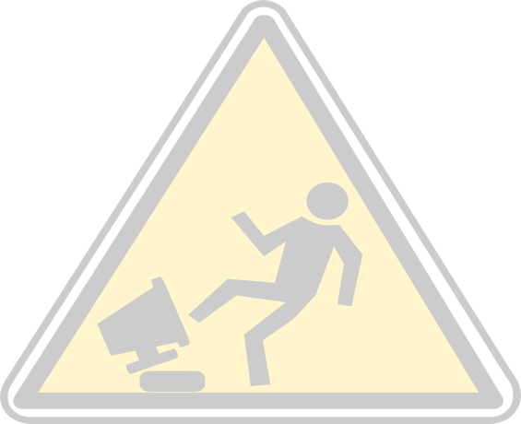
is/ at work? /to feel safe/ it important/ why

What/ at work? / feel safe/ people/makes

1.2 Discuss the questions with your group.

1.3 Complete the sentence

- Keeping safe at work means

Activity 2: Physical or emotional safety?
Look at the list of words. Which do you associate with being physically safe/unsafe (P) or feeling emotionally safe/unsafe (E)? You might think some of the words belong to both (B). Use a dictionary to help you.

- an accident/ an injury | P
- bullying
- communication
- diversity
- employers’ responsibility
- hazards
- policies
- protective clothing
- signs
- trust
- workload
- workers’ rights
- workers’ responsibility
Find out what other people in your group think. Look at the language in the box below to help you ask for somebody's opinion and give your opinion. Can you think of more words connected to both being physically safe and feeling emotionally safe?

Language box: Asking somebody’s opinion
What do you think, is...? What do you reckon, is X ...?
Giving opinions
As far as I know... I could be wrong, but...
I’d say that... I’m pretty sure that...

Activity 3: What are the hazards of being a....?
Think of a job. This could be a job you have done, do or would like to do one day.
Make a note of the hazards of the job. Complete the job card below.

The job: ________________________
Stress Physical hazards Other (e.g., chemical)

Glossary
hazard - something that can be dangerous or cause damage

Compare your job cards. What other hazards can you add to the job cards? How safe do you think people doing this job feel in your country?

Activity 4: Reflection
Discuss the following questions.

How safe do you think workers feel in your country? Do you think workers in other countries feel the same? Why? Why not?
Have you or someone you know ever felt unsafe at work? Why?
Do you know what rights you have to work to be and feel safe at work? If not, how can you find out more about keeping safe at work?

